**Music Store**

**Summary/Proposal:**

* Design a website for artist to add albums and tracks and subscribers, create playlist and tracks.
* The website would be able to register users. The users could either be subscriber or artist.
* Artist can add an album to the Music Library that would be in the pending state, till the admin approves or rejects it.
* The Subscribers can add or delete a playlist. Playlist is a list of tracks.
* Subscribers would be able to search the tracks based on the album or artist name.

**Functionalities:**

* The users when registered, would get an email for activating their account.
* Artists would be able to add their albums or tracks (implemented using SimpleFormController).
* Session Management implemented
* Subscribers can search for any track and add it to his playlist

**Technologies Used:**

* JAVA Spring MVC
* Hibernate
* MS-SQL Database
* J-Query
* AJAX
* HTML5
* CSS3
* BOOTSTRAP
* JAVASCRIPT

**Roles and Respective Tasks**

* Admin
* Will approve/reject albums
* View a generic report of Users
* Artist
* Create and view the status of albums created by him
* Can add track to the albums
* Subscriber
* Can create a playlist
* Can add tracks to the playlist created by him

**Screenshots**

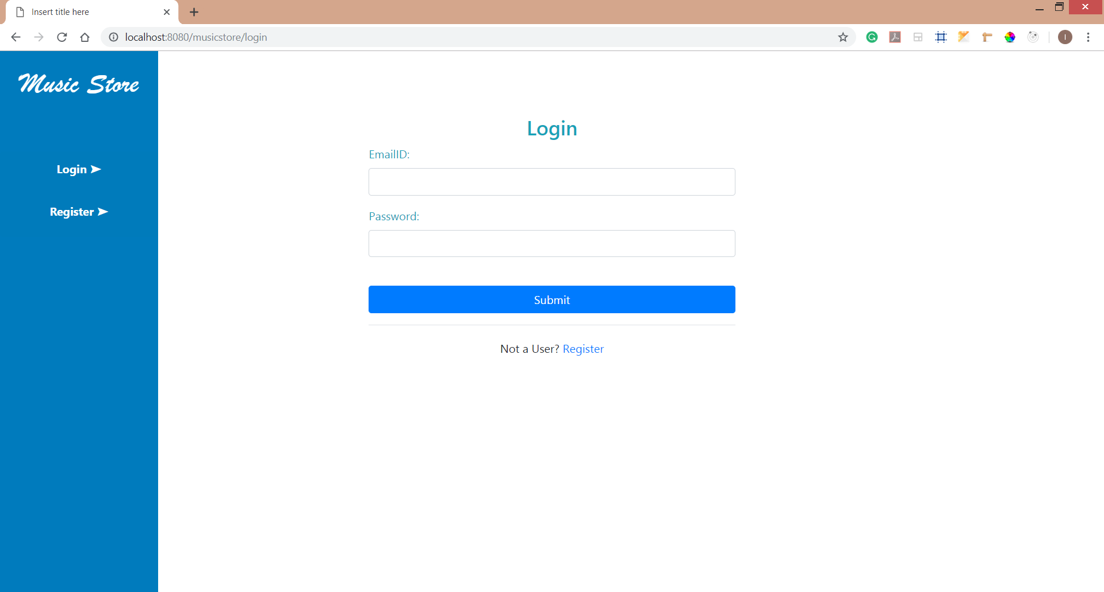

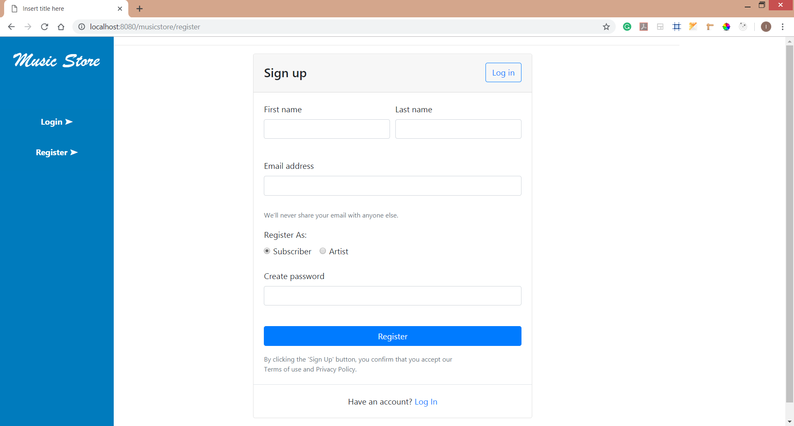

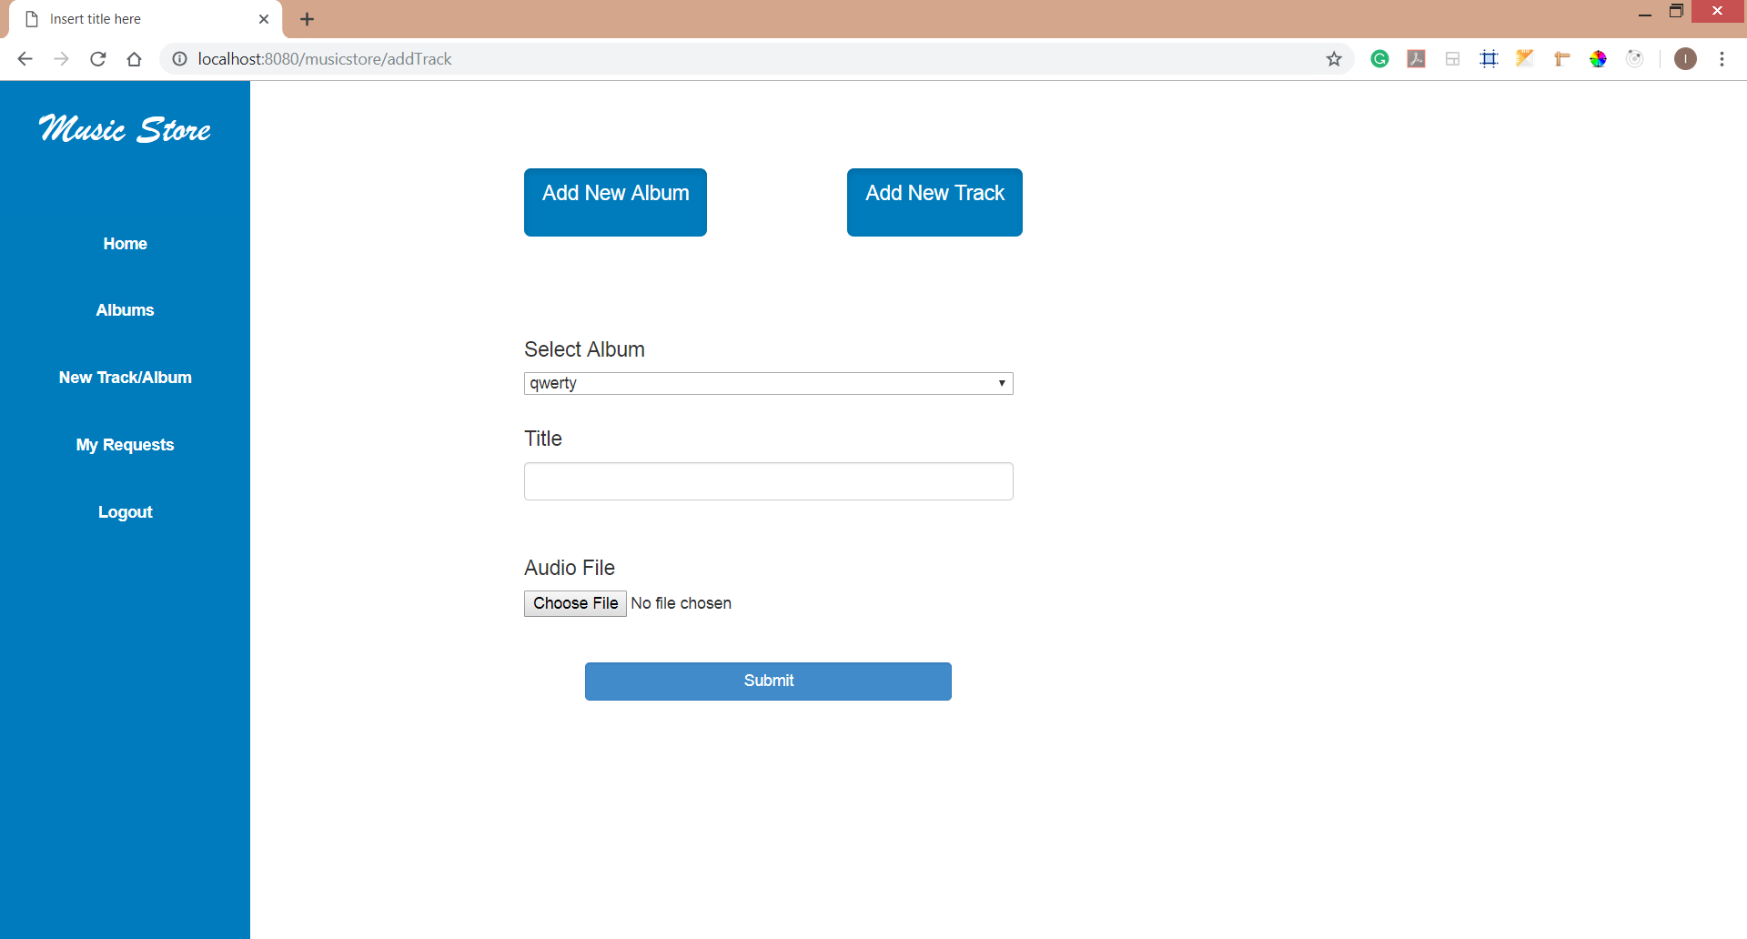

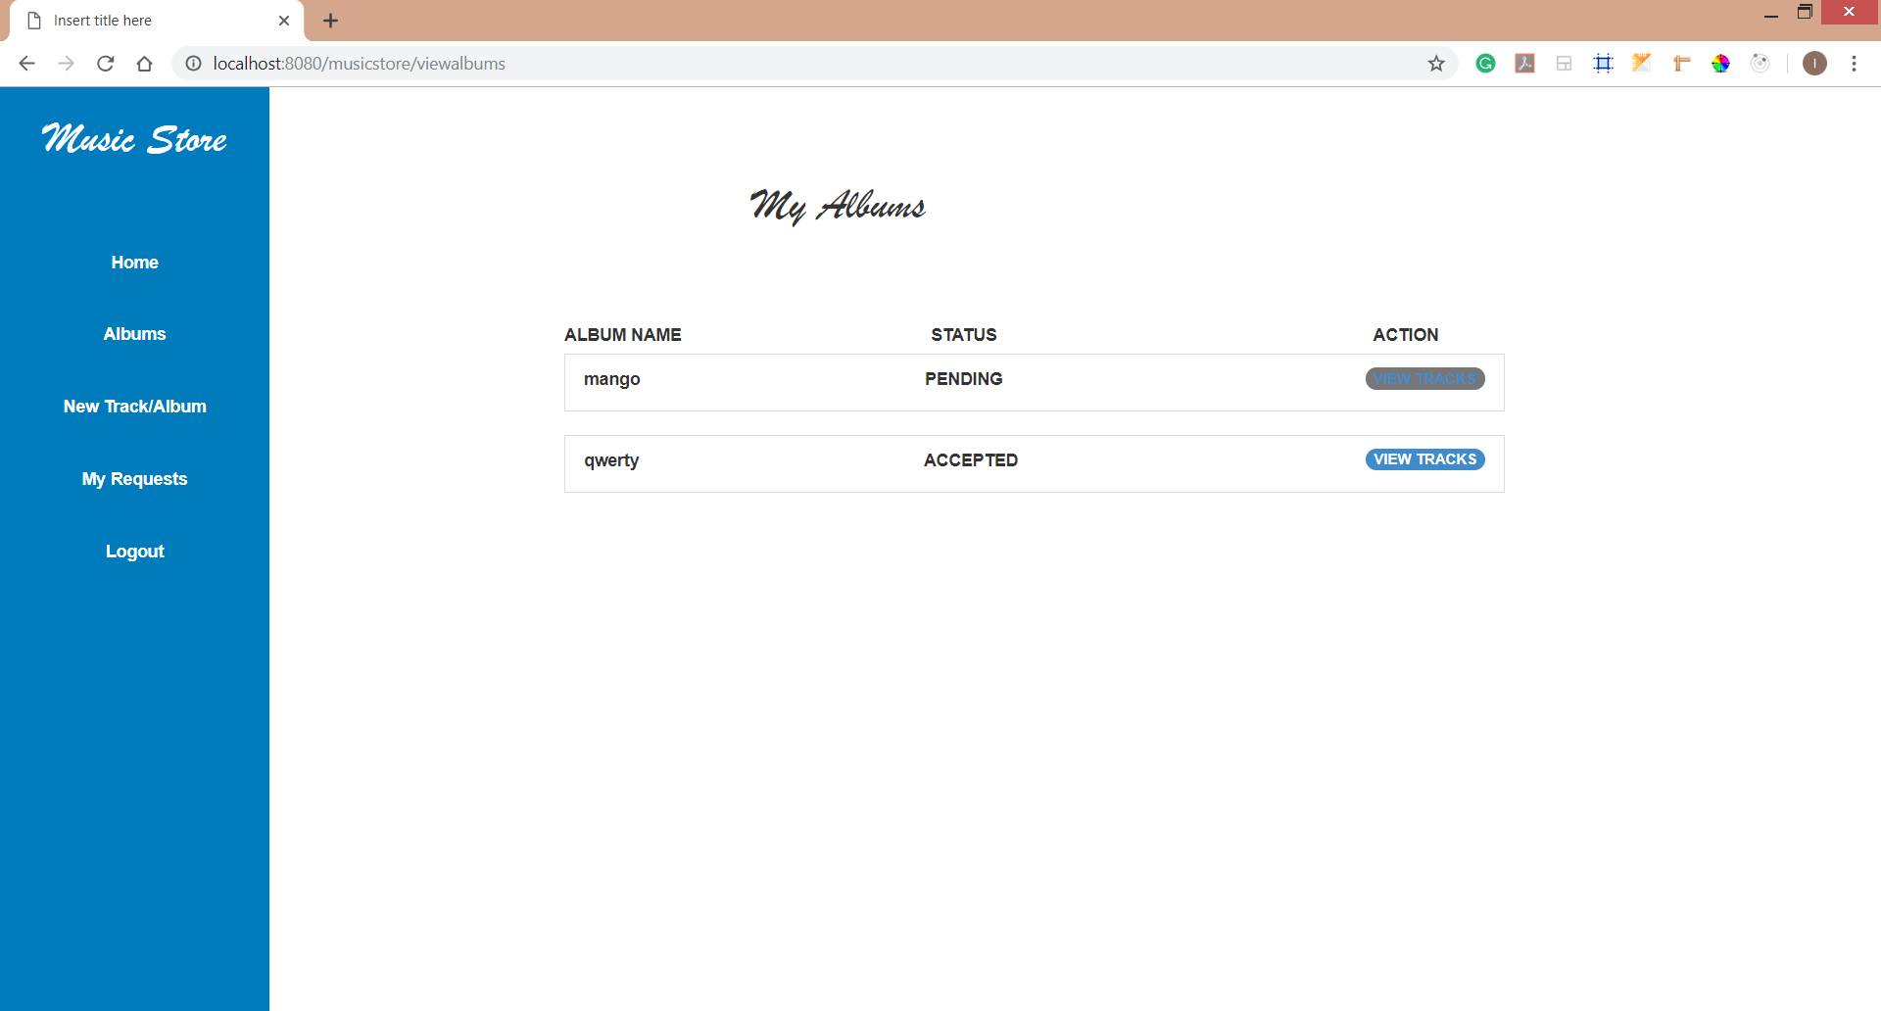

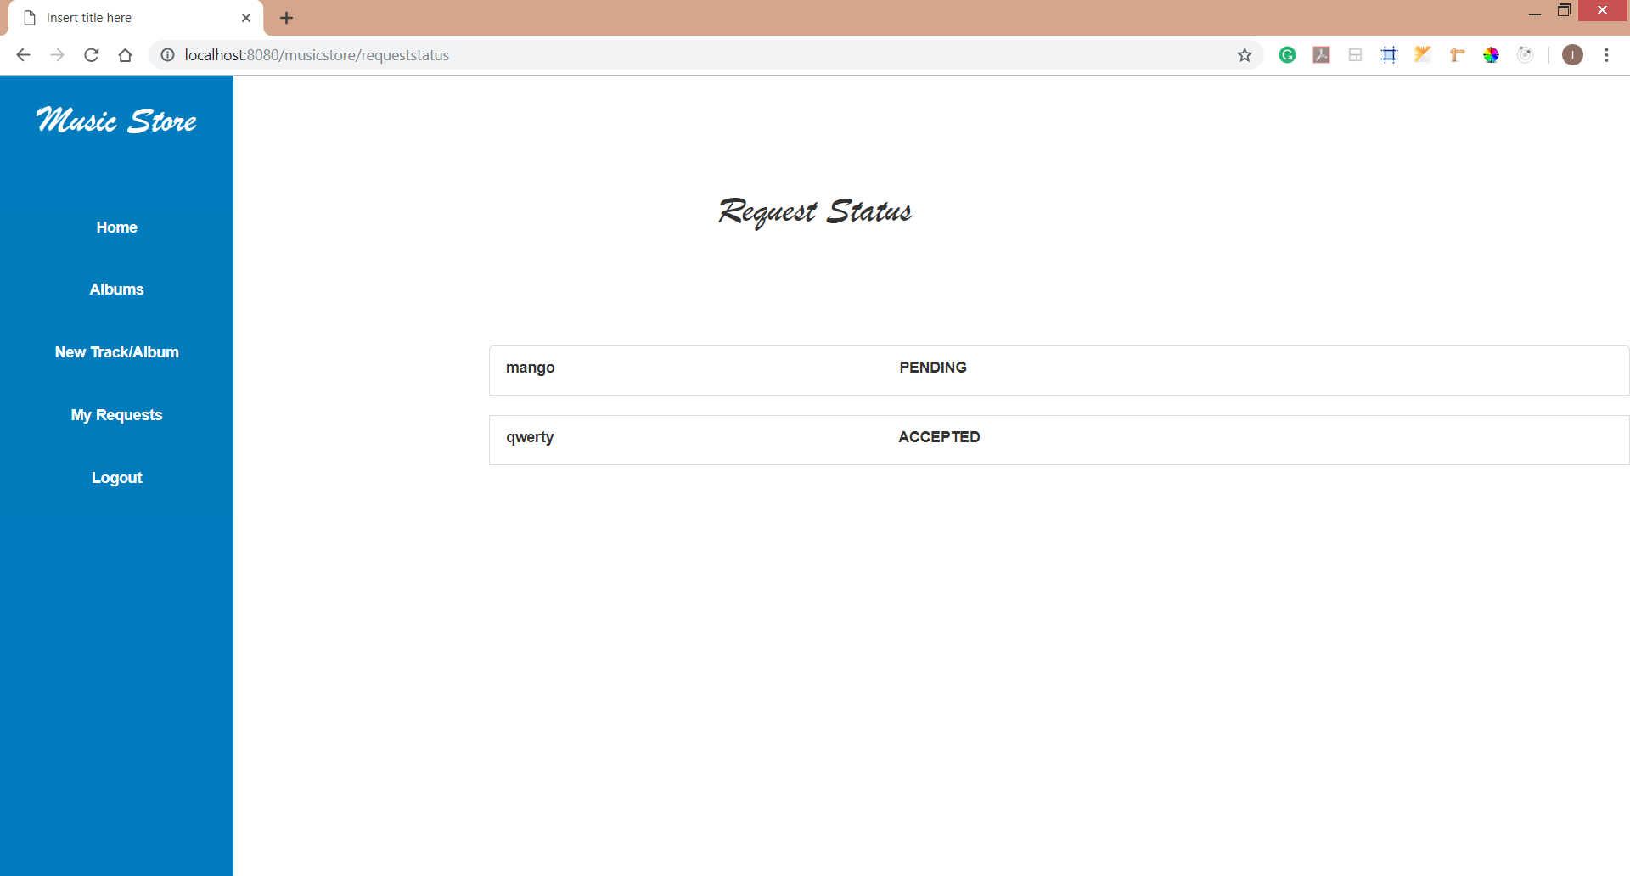

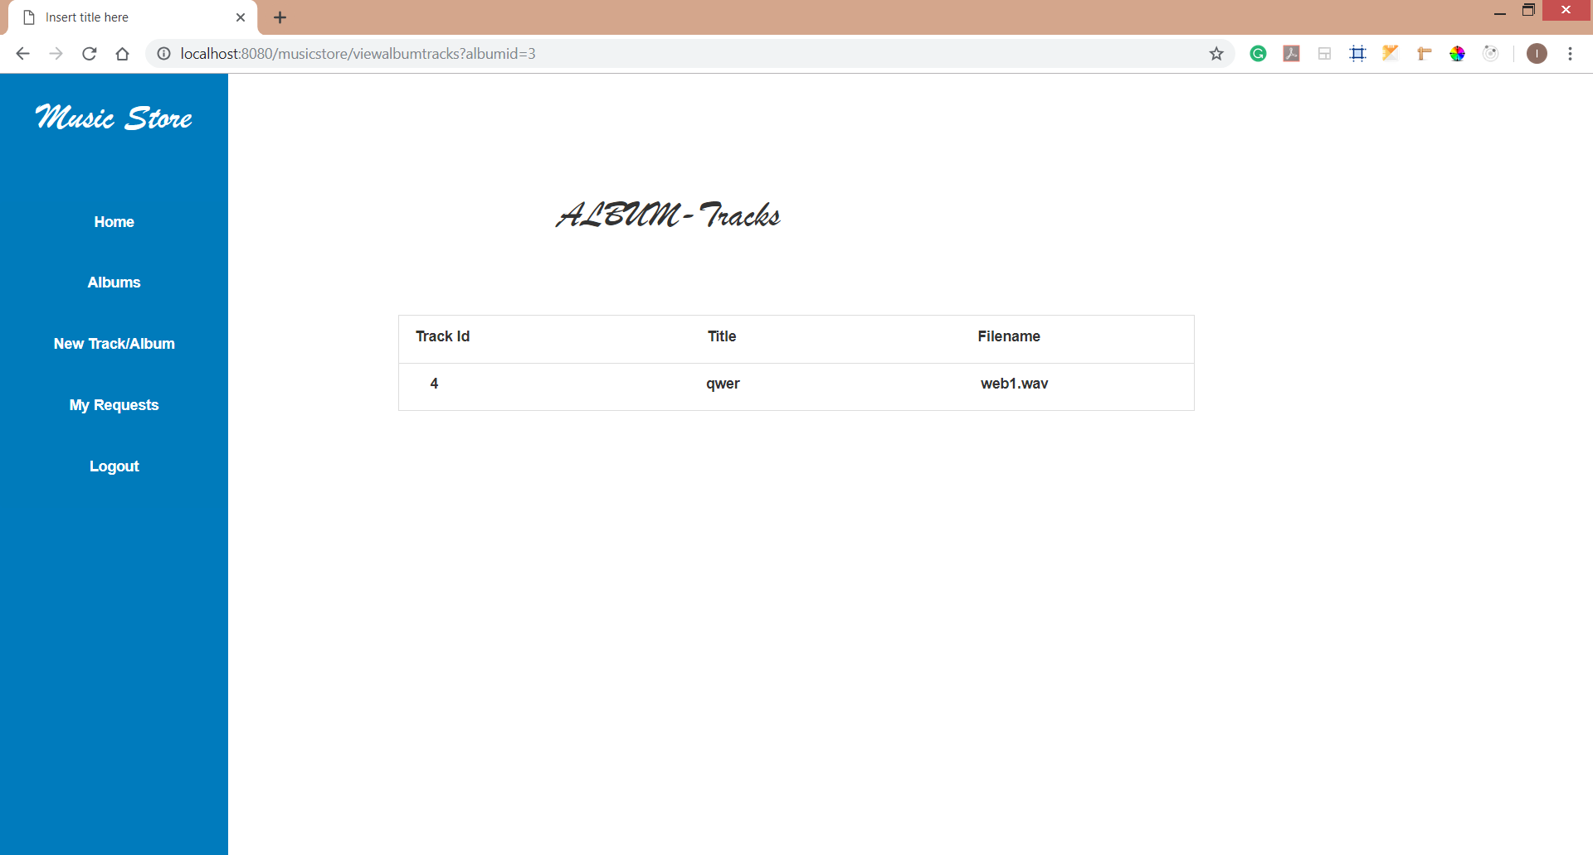

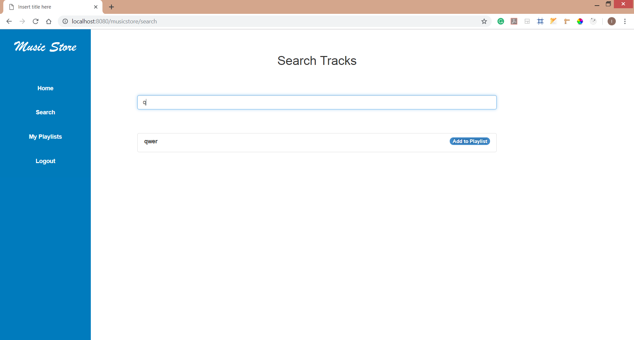

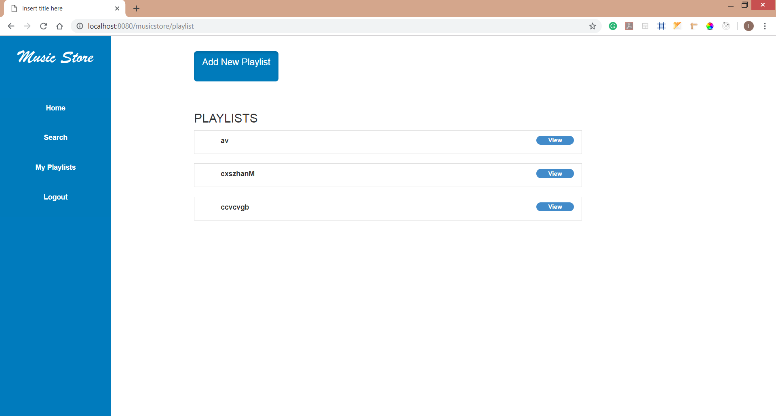

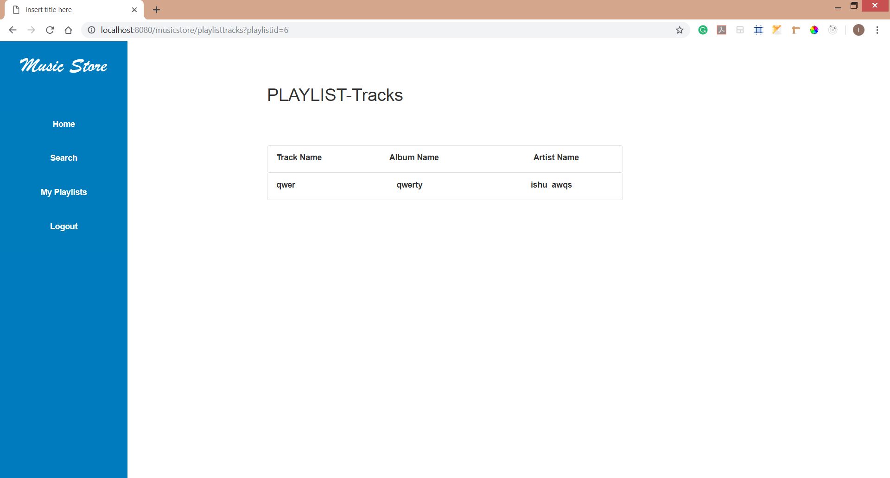

**Appendix:**

**Controllers:**

1. **AdminController**

**package** com.music.musicstore.controllers;

**import** java.util.ArrayList;

**import** java.util.HashMap;

**import** java.util.List;

**import** java.util.Map;

**import** javax.servlet.http.HttpServletRequest;

**import** javax.servlet.http.HttpServletResponse;

**import** org.springframework.stereotype.Controller;

**import** org.springframework.ui.ModelMap;

**import** org.springframework.web.bind.annotation.RequestMapping;

**import** org.springframework.web.bind.annotation.RequestMethod;

**import** org.springframework.web.servlet.ModelAndView;

**import** com.music.musicstore.dao.AlbumDAO;

**import** com.music.musicstore.dao.ArtistDao;

**import** com.music.musicstore.dao.SubscriberDAO;

**import** com.music.musicstore.pojo.Album;

**import** com.music.musicstore.pojo.Artist;

**import** com.music.musicstore.pojo.Subscriber;

**import** com.music.musicstore.pojo.User.UserRole;

@Controller

**public** **class** AdminController {

@RequestMapping(method = RequestMethod.***GET***, value = "/viewartists")

**public** String viewArtists(ArtistDao artistdao, ModelMap map) {

ArrayList<Artist> artistList = artistdao.getAllArtist();

System.***out***.println(artistList.size());

map.put("display", UserRole.***ARTIST***.getRole());

map.addAttribute("userList", artistList);

**return** "viewusers";

}

@RequestMapping(method = RequestMethod.***GET***, value = "/viewsubscribers")

**public** String viewSubscriber(SubscriberDAO subscriberdao, ModelMap map) {

ArrayList<Subscriber> subscriberList = subscriberdao.getAllSubscriber();

System.***out***.println(subscriberList.size());

map.put("display", UserRole.***SUBSCRIBER***.getRole());

map.addAttribute("userList", subscriberList);

**return** "viewusers";

}

@RequestMapping(method = RequestMethod.***GET***, value = "/viewalbumrequests")

**public** String viewAlbumRequests(AlbumDAO albumdao, ModelMap map) {

List<Album> albumlist = albumdao.getviewalbumrequests();

System.***out***.println(albumlist.size());

map.addAttribute("albumlist", albumlist);

**return** "viewalbumrequests";

}

@RequestMapping(method = RequestMethod.***GET***, value = "/deletesubscriber")

**public** String deleteSubscribers(SubscriberDAO subscriberdao, ModelMap map, HttpServletRequest request) {

**int** id = Integer.*parseInt*(request.getParameter("user"));

**int** count = subscriberdao.deleteSubscribers(id);

map.put("display", UserRole.***SUBSCRIBER***.getRole());

**return** "viewusers";

}

@RequestMapping(method = RequestMethod.***GET***, value = "/deleteartist")

**public** String deleteArtist(ArtistDao artistdao, ModelMap map, HttpServletRequest request) {

**int** id = Integer.*parseInt*(request.getParameter("user"));

**int** count = artistdao.deleteartist(id);

**return** "redirect:./viewartists";

}

@RequestMapping(method = RequestMethod.***GET***, value = "/requestalbum")

**public** String requestActions(AlbumDAO albumdao, HttpServletRequest request) {

System.***out***.println("qwer");

String status = request.getParameter("status");

String albumid = request.getParameter("albumid");

**int** count = albumdao.updateAlbumStatus(status, albumid);

**return** "redirect:./viewalbumrequests";

}

@RequestMapping(method = RequestMethod.***GET***, value = "/report")

**protected** ModelAndView handleRequestInternal(HttpServletRequest request, HttpServletResponse response,

ArtistDao artistdao, SubscriberDAO subscriberDAO) **throws** Exception {

Map<String, Object> report = **new** HashMap<String, Object>();

**long** numArtists = (Long) artistdao.getNumberOfArtists().get(0);

report.put("numArtists", numArtists);

List<Artist> artists = artistdao.getAllArtist();

report.put("artists", artists);

**long** numSubscribers = (Long) subscriberDAO.getNumberOfSubscribers().get(0);

report.put("numSubscribers", numSubscribers);

List<Subscriber> subscribers = subscriberDAO.getAllSubscriber();

report.put("subscribers", subscribers);

// return normal view

**return** **new** ModelAndView(**new** PdfReportView(), "report", report);

}

}

1. **ArtistController**

**package** com.music.musicstore.controllers;

**import** java.io.File;

**import** java.io.IOException;

**import** java.util.Calendar;

**import** java.util.List;

**import** java.util.Set;

**import** javax.servlet.http.HttpServletRequest;

**import** javax.servlet.http.HttpSession;

**import** org.springframework.stereotype.Controller;

**import** org.springframework.web.bind.annotation.ModelAttribute;

**import** org.springframework.web.bind.annotation.RequestMapping;

**import** org.springframework.web.bind.annotation.RequestMethod;

**import** com.music.musicstore.dao.AlbumDAO;

**import** com.music.musicstore.dao.TrackDAO;

**import** com.music.musicstore.pojo.Album;

**import** com.music.musicstore.pojo.Artist;

**import** com.music.musicstore.pojo.Track;

**import** com.music.musicstore.pojo.User;

@Controller

**public** **class** ArtistController {

@RequestMapping(value = "/viewalbums", method = RequestMethod.***GET***)

**public** String viewalbums(HttpServletRequest request, AlbumDAO albumdao) {

HttpSession session = request.getSession();

User user = (Artist) session.getAttribute("user");

Set<Album> albumsList = albumdao.getAlbumList(user.getEmail());

System.***out***.println(albumsList.size());

**if** (albumsList != **null**)

request.setAttribute("albumsList", albumsList);

**return** "viewalbums";

}

@RequestMapping(value = "/viewtracks", method = RequestMethod.***GET***)

**public** String viewtracks(HttpServletRequest request, AlbumDAO albumdao) {

**return** "viewtracks";

}

@RequestMapping(value = "/addNew", method = RequestMethod.***GET***)

**public** String addPage(HttpServletRequest request) {

String type = request.getParameter("type");

request.setAttribute("addType", "ALBUM");

**return** "add";

}

@RequestMapping(value = "/add", method = RequestMethod.***POST***)

**public** String add(HttpServletRequest request, AlbumDAO albumdao) {

**if** (request.getParameter("addType").equals("ALBUM")) {

Album album = **new** Album();

Artist artist = (Artist) request.getSession().getAttribute("user");

album.setAlbumName(request.getParameter("albumName"));

album.setArtist((Artist) request.getSession().getAttribute("user"));

artist.getAlbums().add(album);

albumdao.addAlbum(album, artist);

}

**return** "redirect:./homepage";

}

@RequestMapping(value = "/addTrack", method = RequestMethod.***GET***)

**public** String addTrackForm(HttpServletRequest request, AlbumDAO albumdao, Track track) {

HttpSession session = request.getSession();

User user = (Artist) session.getAttribute("user");

List<Album> albums = albumdao.getAlbums(user.getEmail());

**if** (albums != **null**)

request.setAttribute("albums", albums);

request.setAttribute("addType", "TRACK");

**return** "add";

}

@RequestMapping(value = "/addTrack", method = RequestMethod.***POST***)

**public** String addTrack(HttpServletRequest request, AlbumDAO albumdao, @ModelAttribute("track") Track track,

TrackDAO trackDAO) {

**if** (request.getParameter("addType").equals("TRACK")) {

System.***out***.println("Here");

String localPath = "D:\\Web Tools\\ProjectFiles";

String albumId = **null**;

**if** ((albumId = request.getParameter("albumId")) != **null**) {

track.setFileName(Calendar.*getInstance*().getTimeInMillis() + track.getMusic().getOriginalFilename());

File file = **new** File(localPath, track.getFileName());

**try** {

track.getMusic().transferTo(file);

} **catch** (IllegalStateException e) {

System.***out***.println(e.getMessage());

} **catch** (IOException e) {

System.***out***.println(e.getMessage());

}

Album album = albumdao.getAlbum(albumId);

album.getTracks().add(track);

track.setAlbum(album);

trackDAO.addTrack(track, album);

} **else** {

System.***out***.println("Track not uploaded");

}

}

**return** "redirect:./homepage";

}

@RequestMapping(value = "/requeststatus", method = RequestMethod.***GET***)

**public** String requeststatus(HttpServletRequest request, AlbumDAO albumdao) {

HttpSession session = request.getSession();

User user = (Artist) session.getAttribute("user");

Set<Album> albumsList = albumdao.getPendingAlbumList(user.getEmail());

System.***out***.println(albumsList.size());

**if** (albumsList != **null**)

request.setAttribute("albumsList", albumsList);

**return** "requeststatus";

}

@RequestMapping(value = "/add", method = RequestMethod.***GET***)

**public** String addNew(HttpServletRequest request) {

**return** "add";

}

@RequestMapping(value = "/viewalbumtracks", method = RequestMethod.***GET***)

**public** String viewalbumtracks(HttpServletRequest request, AlbumDAO albumdao) {

**int** album_id = Integer.*parseInt*(request.getParameter("albumid"));

List<Track> tracks = albumdao.getviewalbumtracks(album_id);

request.setAttribute("tracks", tracks);

**return** "/viewalbumtracks";

}

}

1. **PdfReportView**

package com.music.musicstore.controllers;

import java.util.List;

import java.util.Map;

import javax.servlet.http.HttpServletRequest;

import javax.servlet.http.HttpServletResponse;

import org.springframework.web.servlet.view.document.AbstractPdfView;

import com.lowagie.text.Chunk;

import com.lowagie.text.Document;

import com.lowagie.text.Paragraph;

import com.lowagie.text.Table;

import com.lowagie.text.pdf.PdfWriter;

import com.music.musicstore.pojo.Artist;

import com.music.musicstore.pojo.Subscriber;

public class PdfReportView extends AbstractPdfView {

@SuppressWarnings("unchecked")

@Override

protected void buildPdfDocument(Map model, Document document, PdfWriter writer, HttpServletRequest request,

HttpServletResponse response) throws Exception {

Map<String, Object> report = (Map<String, Object>) model.get("report");

Table tableArtist = new Table(2);

tableArtist.addCell("Artist");

tableArtist.addCell("Number of Albums");

List<Artist> artists = (List<Artist>) report.get("artists");

for (Artist artist : artists) {

tableArtist.addCell(artist.getFname() + " " + artist.getLname());

tableArtist.addCell(String.valueOf(artist.getAlbums().size()));

}

Table tableSubscriber = new Table(2);

tableSubscriber.addCell("Subscriber");

tableSubscriber.addCell("Number of Playlist");

List<Subscriber> subscribers = (List<Subscriber>) report.get("subscribers");

for (Subscriber subscriber : subscribers) {

tableSubscriber.addCell(subscriber.getFname() + " " + subscriber.getLname());

tableSubscriber.addCell(String.valueOf(subscriber.getPlayList().size()));

}

Paragraph p = new Paragraph(new Chunk("Number of Artists : " + report.get("numArtists")));

document.add(p);

document.add(tableArtist);

p = new Paragraph(new Chunk(" \n "));

p = new Paragraph(new Chunk("Number of Subscribers : " + report.get("numSubscribers")));

document.add(p);

document.add(tableSubscriber);

}

}

1. **RegisterUserController**

**package** com.music.musicstore.controllers;

**import** java.util.Random;

**import** javax.servlet.http.HttpServletRequest;

**import** javax.servlet.http.HttpSession;

**import** org.apache.commons.mail.DefaultAuthenticator;

**import** org.apache.commons.mail.Email;

**import** org.apache.commons.mail.EmailException;

**import** org.apache.commons.mail.SimpleEmail;

**import** org.springframework.beans.factory.annotation.Autowired;

**import** org.springframework.stereotype.Controller;

**import** org.springframework.ui.ModelMap;

**import** org.springframework.validation.BindingResult;

**import** org.springframework.validation.annotation.Validated;

**import** org.springframework.web.bind.WebDataBinder;

**import** org.springframework.web.bind.annotation.InitBinder;

**import** org.springframework.web.bind.annotation.ModelAttribute;

**import** org.springframework.web.bind.annotation.RequestMapping;

**import** org.springframework.web.bind.annotation.RequestMethod;

**import** com.music.musicstore.dao.UserDAO;

**import** com.music.musicstore.pojo.User;

**import** com.music.musicstore.validator.UserValidator;

@Controller

@RequestMapping(value = "register")

**public** **class** RegisterUserController {

@Autowired

UserValidator uservalidator;

@Autowired

UserDAO userdao;

// Set a form validator

@InitBinder

**protected** **void** initBinder(WebDataBinder binder) {

binder.setValidator(uservalidator);

}

@RequestMapping(method = RequestMethod.***GET***)

**public** String formView(ModelMap model, User user) {

model.addAttribute("user", user);

**return** "register";

}

@RequestMapping(method = RequestMethod.***POST***)

**public** String successView(@Validated @ModelAttribute("user") User user, BindingResult bindingResult,

HttpServletRequest request) {

**if** (bindingResult.hasErrors()) {

**return** "register"; // the are validation errors, go to the form view

}

// no errors, so go to the success view

**if** (userdao.getUser(user.getEmail()) != **null**) {

request.setAttribute("error", "Email address already present!!");

**return** "register";

}

HttpSession session = request.getSession();

user.setPassword(String.*valueOf*(user.getPassword().hashCode()));

user = userdao.create(user);

Random rand = **new** Random();

**int** randomNum1 = rand.nextInt(5000000);

**int** randomNum2 = rand.nextInt(5000000);

**try** {

String str = "http://localhost:8080/musicstore/validateemail.htm?email=" + user.getEmail() + "&key1="

+ randomNum1 + "&key2=" + randomNum2;

session.setAttribute("key1", randomNum1);

session.setAttribute("key2", randomNum2);

sendEmail(user.getEmail(), "Click on this link to activate your account : " + str);

} **catch** (Exception e) {

System.***out***.println("Email cannot be sent");

}

request.setAttribute("registration_success",

"Registration Successful!! Please check your email for activation link!!");

**return** "home";

}

**public** **void** sendEmail(String useremail, String message) {

**try** {

Email email = **new** SimpleEmail();

email.setHostName("smtp.googlemail.com");

email.setSmtpPort(465);

email.setAuthenticator(**new** DefaultAuthenticator("wt.musicstore@gmail.com", "wt-mstr@123"));

email.setSSLOnConnect(**true**);

email.setFrom("no-reply@msis.neu.edu"); // This user email does not

// exist

email.setSubject("Password Reminder");

email.setMsg(message); // Retrieve email from the DAO and send this

email.addTo(useremail);

email.send();

} **catch** (EmailException e) {

System.***out***.println(e);

}

}

@RequestMapping(value = "resendemail.htm", method = RequestMethod.***POST***)

**public** String resendEmail(HttpServletRequest request) {

HttpSession session = request.getSession();

String useremail = (String) request.getAttribute("username");

Random rand = **new** Random();

**int** randomNum1 = rand.nextInt(5000000);

**int** randomNum2 = rand.nextInt(5000000);

**try** {

String str = "http://localhost:8080/musicstore/validateemail.htm?email=" + useremail + "&key1=" + randomNum1

+ "&key2=" + randomNum2;

session.setAttribute("key1", randomNum1);

session.setAttribute("key2", randomNum2);

sendEmail(useremail, "Click on this link to activate your account : " + str);

} **catch** (Exception e) {

System.***out***.println("Email cannot be sent");

}

**return** "user-created";

}

}

1. **SearchController**

**package** com.music.musicstore.controllers;

**import** java.util.List;

**import** javax.servlet.http.HttpServletRequest;

**import** org.springframework.stereotype.Controller;

**import** org.springframework.web.bind.annotation.RequestMapping;

**import** org.springframework.web.bind.annotation.RequestMethod;

**import** org.springframework.web.bind.annotation.ResponseBody;

**import** com.fasterxml.jackson.core.JsonProcessingException;

**import** com.fasterxml.jackson.databind.ObjectMapper;

**import** com.music.musicstore.dao.AlbumDAO;

**import** com.music.musicstore.dao.TrackDAO;

**import** com.music.musicstore.pojo.Track;

@Controller

**public** **class** SearchController {

@RequestMapping(value = "/searchTrack", method = RequestMethod.***GET***, produces = "application/json")

@ResponseBody

**public** String searchArtist(HttpServletRequest request, TrackDAO trackdao, AlbumDAO albumdao)

**throws** JsonProcessingException {

String param = request.getParameter("search");

List<Track> tracks = trackdao.getTracks(param);

ObjectMapper obj = **new** ObjectMapper();

**return** obj.writeValueAsString(tracks);

}

}

1. **SubscriberController**

package com.music.musicstore.controllers;

import java.util.ArrayList;

import java.util.List;

import java.util.Set;

import javax.servlet.http.HttpServletRequest;

import org.springframework.stereotype.Controller;

import org.springframework.ui.ModelMap;

import org.springframework.web.bind.annotation.RequestMapping;

import org.springframework.web.bind.annotation.RequestMethod;

import com.music.musicstore.dao.PlayListDAO;

import com.music.musicstore.dao.SubscriberDAO;

import com.music.musicstore.dao.TrackDAO;

import com.music.musicstore.pojo.PlayList;

import com.music.musicstore.pojo.Subscriber;

import com.music.musicstore.pojo.Track;

import com.music.musicstore.pojo.User;

@Controller

public class SubscriberController {

@RequestMapping(value = "/search", method = RequestMethod.GET)

public String searchTrack() {

return "search";

}

@RequestMapping(value = "playlist", method = RequestMethod.GET)

public String playlist(HttpServletRequest request, PlayListDAO playListDAO) {

request.setAttribute("addType", "VIEW_PLAYLIST");

List<PlayList> playlists = playListDAO

.getPlaylists(((User) request.getSession().getAttribute("user")).getEmail());

if (playlists == null) {

playlists = new ArrayList<PlayList>();

}

request.setAttribute("playlists", playlists);

return "playlist";

}

@RequestMapping(value = "/addNewPlaylist", method = RequestMethod.GET)

public String addPlaylist(HttpServletRequest request) {

request.setAttribute("addType", "PLAYLIST");

return "playlist";

}

@RequestMapping(value = "/addNewPlaylist", method = RequestMethod.POST)

public String addNewPlaylist(HttpServletRequest request, PlayListDAO playlistdao) {

// User user = (User) request.getSession().getAttribute("user");

PlayList playlist = new PlayList();

Subscriber subscriber = (Subscriber) request.getSession().getAttribute("user");

boolean present = false;

for (PlayList p : subscriber.getPlayList()) {

if (p.getPlayListName().equalsIgnoreCase(request.getParameter("playlistName"))) {

present = true;

break;

}

}

if (!present) {

playlist.setPlayListName(request.getParameter("playlistName"));

playlist.setSubscriber(subscriber);

subscriber.getPlayList().add(playlist);

playlistdao.addPlaylist(playlist, subscriber);

return "redirect:./playlist";

} else {

request.setAttribute("errormessage", "Playlist with same name already present!!");

request.setAttribute("addType", "PLAYLIST");

return "playlist";

}

}

@RequestMapping(value = "/deletePlaylist", method = RequestMethod.GET)

public String deletePlaylist(HttpServletRequest request, PlayListDAO playlistdao) {

request.setAttribute("addType", "VIEW_PLAYLIST");

int id = Integer.parseInt(request.getParameter("playlistid"));

int count = playlistdao.deletePlaylist(id);

return "playlist";

}

@RequestMapping(value = "/accountsettings", method = RequestMethod.GET)

public String accountSettings() {

return "accountsettings";

}

@RequestMapping(method = RequestMethod.GET, value = "/playlisttracks")

public String requestActions(PlayListDAO playlistdao, HttpServletRequest request) {

System.out.println("qwergbhjknsm");

String playlistid = request.getParameter("playlistid");

Set<Track> tracks = playlistdao.playlisttracks(playlistid);

request.setAttribute("tracks", tracks);

System.out.println(playlistid);

request.setAttribute("playlistid", playlistid);

return "viewtracks";

}

@RequestMapping(method = RequestMethod.GET, value = "/addtrackstoplaylist")

public String addtrackstoplaylist(TrackDAO trackdao, HttpServletRequest request, ModelMap map,

SubscriberDAO subscriberdao) {

System.out.println(request.getParameter("trackid"));

Track track = trackdao.getTrack(Integer.parseInt(request.getParameter("trackid")));

System.out.println(track.getTitle());

map.put("track", track);

Subscriber subscriber = subscriberdao

.getSubscriber(((User) request.getSession().getAttribute("user")).getEmail());

map.put("playlists", subscriber.getPlayList());

return "addtrackstoplaylist";

}

@RequestMapping(method = RequestMethod.GET, value = "/addToPlylist")

public String addtoplaylist(TrackDAO trackdao, HttpServletRequest request, ModelMap map, PlayListDAO playListDAO) {

System.out.println("qwergbhjknsm");

Track track = trackdao.getTrack(Integer.parseInt(request.getParameter("trackid")));

PlayList playList = playListDAO.getplaylist(Integer.parseInt(request.getParameter("playlist")));

if (track != null && playList != null) {

playList.getTracks().add(track);

}

playListDAO.updatePlayList(playList);

return "redirect:./playlist";

}

@RequestMapping(method = RequestMethod.GET, value = "/deleteTrackFromPlaylist")

public String deleteTrackFromPlaylist(TrackDAO trackdao, HttpServletRequest request, ModelMap map,

PlayListDAO playListDAO) {

System.out.println(request.getParameter("playlistid"));

Track track = trackdao.getTrack(Integer.parseInt(request.getParameter("trackid")));

PlayList playList = playListDAO.getplaylist(Integer.parseInt(request.getParameter("playlistid")));

if (track != null && playList != null) {

playList.getTracks().remove(track);

}

playListDAO.updatePlayList(playList);

return "redirect:./playlist";

}

}

1. **UserController**

package com.music.musicstore.controllers;

import java.io.IOException;

import javax.servlet.http.HttpServletRequest;

import javax.servlet.http.HttpServletResponse;

import javax.servlet.http.HttpSession;

import org.springframework.beans.factory.annotation.Autowired;

import org.springframework.stereotype.Controller;

import org.springframework.ui.ModelMap;

import org.springframework.web.bind.annotation.RequestMapping;

import org.springframework.web.bind.annotation.RequestMethod;

import com.music.musicstore.dao.UserDAO;

import com.music.musicstore.pojo.User;

@Controller

public class UserController {

@Autowired

UserDAO userdao;

@RequestMapping(method = RequestMethod.GET, value = "/login")

public String login() {

return "home";

}

@RequestMapping(method = RequestMethod.GET, value = "/home")

public String home() {

return "home";

}

@RequestMapping(method = RequestMethod.GET, value = "/homepage")

public String homepage(HttpServletRequest request) {

User user = (User) request.getSession().getAttribute("user");

System.out.println("here");

if (user == null) {

return "redirect:./home";

} else {

if (user.getRole().equals(User.UserRole.ADMIN.getRole())) {

return "admin-view";

} else if (user.getRole().equals(User.UserRole.ARTIST.getRole())) {

return "artist-view";

} else {

return "subscriber-view";

}

}

}

@RequestMapping(method = RequestMethod.POST, value = "/home")

public String loginandRegister(HttpServletRequest request, HttpServletResponse response) throws IOException {

HttpSession session = request.getSession();

System.out.println("inside user login");

String email = (String) request.getAttribute("email");

String password = (String) request.getAttribute("password");

System.out.println(password);

password = String.valueOf(password.hashCode());

User user = userdao.login(email, password);

if (user == null) {

request.setAttribute("login_error", "Invalid Credentials");

return "home";

} else {

if (user.getStatus() == 0) {

request.setAttribute("login_error",

"Please activate the account using the link sent to your email first!!");

return "home";

}

session.setAttribute("user", user);

if (user.getRole().equals(User.UserRole.ADMIN.getRole())) {

return "admin-view";

} else if (user.getRole().equals(User.UserRole.ARTIST.getRole())) {

return "artist-view";

} else {

return "subscriber-view";

}

}

}

@RequestMapping(value = "validateemail.htm", method = RequestMethod.GET)

public String validateEmail(HttpServletRequest request, ModelMap map) {

System.out.println("Hererererererere");

// The user will be sent the following link when the use registers

// This is the format of the email

// http://hostname:8080/musicstore/validateemail.htm?email=useremail&key1=<random_number>&key2=<body

// of the email that when user registers>

HttpSession session = request.getSession();

String email = (String) request.getParameter("email");

int key1 = Integer.parseInt((String) request.getParameter("key1"));

int key2 = Integer.parseInt((String) request.getParameter("key2"));

System.out.println(session.getAttribute("key1"));

System.out.println(session.getAttribute("key2"));

if ((Integer) (session.getAttribute("key1")) == key1 && ((Integer) session.getAttribute("key2")) == key2) {

try {

System.out.println("HI________");

boolean updateStatus = userdao.updateUser(email);

if (updateStatus) {

return "home";

} else {

return "error";

}

} catch (Exception e) {

// TODO Auto-generated catch block

e.printStackTrace();

}

} else {

map.addAttribute("errorMessage", "Link expired , generate new link");

map.addAttribute("resendLink", true);

return "error";

}

return "home";

}

@RequestMapping(value = "/logout", method = RequestMethod.GET)

public String logoutUser(HttpServletRequest request) {

request.getSession().removeAttribute("user");

return "home";

}

}

**DAO:**

1. **AlbumDAO**

package com.music.musicstore.dao;

import java.util.ArrayList;

import java.util.HashSet;

import java.util.List;

import java.util.Set;

import org.hibernate.Criteria;

import org.hibernate.Query;

import org.hibernate.criterion.Restrictions;

import com.music.musicstore.pojo.Album;

import com.music.musicstore.pojo.Artist;

import com.music.musicstore.pojo.Track;

public class AlbumDAO extends DAO {

public Album addAlbum(Album album, Artist artist) {

try {

begin();

getSession().save(album);

getSession().save(artist);

commit();

} catch (Exception e) {

System.out.println(e);

}

close();

return album;

}

@SuppressWarnings("deprecation")

public List<Album> getAlbums(String email) {

try {

begin();

Criteria criteriaArtist = getSession().createCriteria("artist");

Criteria criteriaAlbum = getSession().createCriteria(Album.class);

criteriaArtist.add(Restrictions.eq("email", email));

criteriaAlbum.add(Restrictions.eq("status", "ACCEPTED"));

List<Album> list = criteriaAlbum.list();

close();

if (list.size() == 0) {

return new ArrayList<Album>();

}

return list;

} catch (Exception e) {

System.out.println(e);

close();

}

return null;

}

public Album getAlbum(String albumId) {

begin();

Query q = getSession().createQuery("from Album where album_id = :albumId ");

q.setParameter("albumId", Integer.parseInt(albumId));

Album album = (Album) q.uniqueResult();

close();

return album;

}

public Set<Album> getAlbumList(String email) {

try {

begin();

Query query = getSession().createQuery(" from Artist where email =:email").setParameter("email", email);

query.setMaxResults(1);

List<Artist> list = query.list();

close();

if (list.size() == 0) {

return new HashSet<Album>();

}

return list.get(0).getAlbums();

} catch (Exception e) {

System.out.println(e);

close();

}

return null;

}

public Set<Album> getPendingAlbumList(String email) {

try {

begin();

Criteria crit = getSession().createCriteria(Artist.class);

Criteria albumcriteria = crit.createCriteria("albums");

crit.add(Restrictions.eq("email", email));

albumcriteria.add(Restrictions.eq("status", "PENDING"));

crit.setMaxResults(1);

List<Artist> list = crit.list();

close();

if (list.size() == 0) {

return new HashSet<Album>();

}

return list.get(0).getAlbums();

} catch (Exception e) {

System.out.println(e);

close();

}

return null;

}

public List<Album> getviewalbumrequests() {

try {

begin();

Query q = getSession().createQuery("from Album where status=:status").setParameter("status", "PENDING");

List<Album> album = q.list();

close();

if (album.size() == 0) {

return new ArrayList();

}

return album;

} catch (Exception e) {

System.out.println(e);

close();

}

return null;

}

public int updateAlbumStatus(String status, String albumid) {

// TODO Auto-generated method stub

int count = 0;

try {

begin();

Query q = getSession().createQuery("update Album set status=:status where album_id=:albumid")

.setParameter("status", status);

q.setParameter("albumid", Integer.parseInt(albumid));

count = q.executeUpdate();

System.out.println("count" + count);

commit();

} catch (Exception e) {

System.out.println(e.getMessage());

} finally {

close();

}

return count;

}

public List<Track> getviewalbumtracks(int album_id) {

try {

begin();

Query q = getSession().createQuery("from Track");

List<Track> tracks = q.list();

List<Track> albumTracks = new ArrayList();

for (Track t : tracks) {

if (t.getAlbum().getAlbum_id() == album_id) {

albumTracks.add(t);

}

}

close();

return albumTracks;

} catch (Exception e) {

System.out.println(e.getMessage());

}

return null;

// return tracks;

}

}

1. **ArtistDAO**

**package** com.music.musicstore.dao;

**import** java.util.ArrayList;

**import** java.util.List;

**import** org.hibernate.Criteria;

**import** org.hibernate.~~Query~~;

**import** org.hibernate.criterion.Projections;

**import** com.music.musicstore.pojo.Artist;

**public** **class** ArtistDao **extends** DAO {

@SuppressWarnings({ "deprecation", "unchecked" })

**public** ArrayList<Artist> getAllArtist() {

ArrayList<Artist> artistList = **new** ArrayList<Artist>();

**try** {

*begin*();

~~Query~~ q = *getSession*().createQuery("from Artist");

artistList = (ArrayList<Artist>) q.~~list~~();

System.***out***.println(artistList.size() + "fgbhnm,zxmncfb");

*close*();

} **catch** (Exception e) {

System.***out***.println(e);

*close*();

}

**return** artistList;

}

**public** **int** deleteartist(**int** id) {

**int** count = 0;

**try** {

*begin*();

~~Query~~ q = *getSession*().createQuery("delete from Artist where id=:id").setParameter("id", id);

count = q.executeUpdate();

} **catch** (Exception e) {

} **finally** {

*close*();

}

**return** count;

}

**public** List getNumberOfArtists() {

List result = **null**;

**try** {

*begin*();

Criteria crit = *getSession*().~~createCriteria~~(Artist.**class**);

crit.setProjection(Projections.*rowCount*());

result = crit.list();

System.***out***.println("Result : " + result);

} **catch** (Exception e) {

System.***out***.println(e.getMessage());

} **finally** {

*close*();

}

**return** result;

}

}

1. **DAO**

package com.music.musicstore.dao;

import java.util.logging.Level;

import java.util.logging.Logger;

import org.hibernate.HibernateException;

import org.hibernate.Session;

import org.hibernate.SessionFactory;

import org.hibernate.cfg.Configuration;

public class DAO {

private static final Logger log = Logger.getAnonymousLogger();

private static final ThreadLocal sessionThread = new ThreadLocal();

private static final SessionFactory sessionFactory = new Configuration().configure("hibernate.cfg.xml")

.buildSessionFactory();

protected DAO() {

}

public static Session getSession() {

Session session = (Session) DAO.sessionThread.get();

if (session == null) {

session = sessionFactory.openSession();

DAO.sessionThread.set(session);

}

return session;

}

public static void begin() {

getSession().beginTransaction();

}

public static void commit() {

getSession().getTransaction().commit();

}

protected void rollback() {

try {

getSession().getTransaction().rollback();

} catch (HibernateException e) {

log.log(Level.WARNING, "Cannot rollback", e);

}

try {

getSession().close();

} catch (HibernateException e) {

log.log(Level.WARNING, "Cannot close", e);

}

DAO.sessionThread.set(null);

}

public static void close() {

getSession().close();

DAO.sessionThread.set(null);

}

}

1. **PlayListDAO**

package com.music.musicstore.dao;

import java.util.ArrayList;

import java.util.List;

import java.util.Set;

import org.hibernate.Criteria;

import org.hibernate.criterion.Restrictions;

import org.hibernate.query.Query;

import com.music.musicstore.pojo.PlayList;

import com.music.musicstore.pojo.Subscriber;

import com.music.musicstore.pojo.Track;

public class PlayListDAO extends DAO {

public PlayList addPlaylist(PlayList playlist, Subscriber subscriber) {

try {

begin();

getSession().save(playlist);

getSession().save(subscriber);

commit();

} catch (Exception e) {

System.out.println(e);

}

close();

return playlist;

}

@SuppressWarnings("deprecation")

public List<PlayList> getPlaylists(String email) {

try {

begin();

Criteria criteria = getSession().createCriteria(PlayList.class);

Criteria criteriaSubscriber = getSession().createCriteria("subscriber");

criteriaSubscriber.add(Restrictions.eq("email", email));

List<PlayList> list = criteria.list();

close();

if (list.size() == 0) {

return new ArrayList<PlayList>();

}

return list;

} catch (Exception e) {

System.out.println(e);

close();

}

return null;

}

public int deletePlaylist(int id) {

int count = 0;

try {

begin();

Query q = getSession().createQuery("delete from PlayList where playlist_Id=:id").setParameter("id", id);

count = q.executeUpdate();

commit();

} catch (Exception e) {

} finally {

close();

}

return count;

}

public Set<Track> playlisttracks(String playlistid) {

Set<Track> tracks = null;

try {

Query q = getSession().createQuery("from PlayList where playlist_Id=:playlistid").setParameter("playlistid",

Integer.parseInt(playlistid));

tracks = ((PlayList) q.uniqueResult()).getTracks();

} catch (Exception e) {

System.out.println(e);

} finally {

close();

}

return tracks;

}

public PlayList getplaylist(int playlistid) {

PlayList playList = null;

try {

Query q = getSession().createQuery("from PlayList where playlist_Id=:playlistid").setParameter("playlistid",

playlistid);

playList = (PlayList) q.uniqueResult();

} catch (Exception e) {

System.out.println(e);

} finally {

close();

}

return playList;

}

public void updatePlayList(PlayList playlist) {

try {

begin();

getSession().saveOrUpdate(playlist);

commit();

} catch (Exception e) {

System.out.println(e);

} finally {

close();

}

}

}

1. **SubscriberDAO**

**package** com.music.musicstore.dao;

**import** java.util.ArrayList;

**import** java.util.List;

**import** org.hibernate.Criteria;

**import** org.hibernate.criterion.Projections;

**import** org.hibernate.query.Query;

**import** com.music.musicstore.pojo.Subscriber;

**public** **class** SubscriberDAO **extends** DAO {

@SuppressWarnings({ "deprecation", "unchecked" })

**public** ArrayList<Subscriber> getAllSubscriber() {

ArrayList<Subscriber> subscriberList = **new** ArrayList<Subscriber>();

**try** {

*begin*();

Query<Subscriber> q = *getSession*().createQuery("from Subscriber");

subscriberList = (ArrayList<Subscriber>) q.list();

*close*();

} **catch** (Exception e) {

System.***out***.println(e);

*close*();

}

**return** subscriberList;

}

**public** **int** deleteSubscribers(**int** id) {

**int** count = 0;

**try** {

*begin*();

Query q = *getSession*().createQuery("delete from PlayList where id=:id").setParameter("id", id);

count = q.executeUpdate();

*commit*();

} **catch** (Exception e) {

} **finally** {

*close*();

}

**return** count;

}

**public** Subscriber getSubscriber(String email) {

// **TODO** Auto-generated method stub

Subscriber subscriber = **null**;

**try** {

*begin*();

Query query = *getSession*().createQuery("from Subscriber where email=:email");

query.setParameter("email", email);

subscriber = (Subscriber) query.uniqueResult();

} **catch** (Exception e) {

System.***out***.println(e.getMessage());

} **finally** {

*close*();

}

**return** subscriber;

}

**public** List getNumberOfSubscribers() {

List result = **null**;

**try** {

*begin*();

Criteria crit = *getSession*().~~createCriteria~~(Subscriber.**class**);

crit.setProjection(Projections.*rowCount*());

result = crit.list();

System.***out***.println("Result : " + result);

} **catch** (Exception e) {

System.***out***.println(e.getMessage());

} **finally** {

*close*();

}

**return** result;

}

}

1. **TrackDAO**

package com.music.musicstore.dao;

import java.util.List;

import org.hibernate.Query;

import com.music.musicstore.pojo.Album;

import com.music.musicstore.pojo.Track;

public class TrackDAO extends DAO {

public Track addTrack(Track track, Album album) {

try {

begin();

getSession().saveOrUpdate(album);

getSession().save(track);

commit();

} catch (Exception e) {

System.out.println(e);

}

close();

return track;

}

public List<Track> getTracks(String param) {

List<Track> tracks = null;

try {

begin();

Query q = getSession().createQuery("from Track where title like '%" + param + "%'");

// q.setParameter("title", "%"+param+"%");

System.out.println(q.toString());

tracks = q.list();

} catch (Exception e) {

System.out.println(e.getMessage());

} finally {

close();

}

return tracks;

}

public Track getTrack(int parameter) {

// TODO Auto-generated method stub

Track track = null;

try {

begin();

Query q = getSession().createQuery("from Track where track_Id=:trackid");

q.setParameter("trackid", parameter);

track = (Track) q.uniqueResult();

} catch (Exception e) {

System.out.println(e.getMessage());

} finally {

close();

}

return track;

}

}

1. **UserDAO**

package com.music.musicstore.dao;

import org.hibernate.Criteria;

import org.hibernate.HibernateException;

import org.hibernate.Query;

import org.hibernate.criterion.Restrictions;

import com.music.musicstore.pojo.Artist;

import com.music.musicstore.pojo.Subscriber;

import com.music.musicstore.pojo.User;

import com.music.musicstore.pojo.User.UserRole;

@SuppressWarnings("deprecation")

public class UserDAO extends DAO {

public User getUser(String email) {

User user1 = null;

try {

begin();

Query q = getSession().createQuery("from User where email = '" + email + "'");

user1 = (User) q.uniqueResult();

if (user1 == null) {

Criteria crit = getSession().createCriteria(Artist.class);

crit.add(Restrictions.eq("email", email));

crit.setMaxResults(1);

user1 = (User) crit.uniqueResult();

}

if (user1 == null) {

Criteria crit = getSession().createCriteria(Subscriber.class);

crit.add(Restrictions.eq("email", email));

crit.setMaxResults(1);

user1 = (User) crit.uniqueResult();

}

} catch (Exception e) {

rollback();

System.out.println(e.getMessage());

} finally {

close();

}

return user1;

}

// to save user when registered

public User create(User user) {

try {

begin();

if (user.getRole().equals(UserRole.ARTIST.getRole())) {

Artist artist = new Artist(user);

getSession().save(artist);

} else {

if (user.getRole().equals(UserRole.SUBSCRIBER.getRole())) {

Subscriber subscriber = new Subscriber(user);

getSession().save(subscriber);

}

}

commit();

} catch (Exception e) {

rollback();

} finally {

close();

}

return user;

}

public User login(String email, String password) {

User user = null;

try {

user = this.getUser(email);

if (!user.getPassword().equals(password)) {

user = null;

}

} catch (Exception e) {

rollback();

System.out.println(e);

} finally {

close();

}

return user;

}

@SuppressWarnings({ "rawtypes", "unused" })

public boolean updateUser(String email) throws Exception {

try {

begin();

System.out.println(email);

Query q = getSession().createQuery("from User where email = :email");

q.setString("email", email);

User user = (User) q.uniqueResult();

System.out.println("ID: " + user.getId());

if (user != null) {

System.out.println("ABC-------------");

user.setStatus(1);

getSession().update(user);

commit();

close();

return true;

}

} catch (HibernateException e) {

rollback();

close();

throw new Exception("Exception while creating user: " + e.getMessage());

}

return false;

}

}

**Interceptor:**

1. **LoginInterceptor**

package com.music.musicstore.interceptor;

import javax.servlet.http.HttpServletRequest;

import javax.servlet.http.HttpServletResponse;

import org.springframework.web.servlet.ModelAndView;

import org.springframework.web.servlet.handler.HandlerInterceptorAdapter;

import com.music.musicstore.pojo.User;

public class LoginInterceptor extends HandlerInterceptorAdapter {

@Override

public boolean preHandle(HttpServletRequest request, HttpServletResponse response, Object handler)

throws Exception {

String uri = request.getRequestURI();

User user = (User) request.getSession().getAttribute("user");

System.out.println(uri);

if (uri.endsWith("login") || uri.endsWith("register") || uri.endsWith(".htm")) {

if (user == null) {

return true;

} else {

response.sendRedirect("./homepage");

System.out.println("here1");

return false;

}

} else {

if (uri.endsWith("home")) {

return true;

} else {

if (user == null) {

response.sendRedirect("./login");

return false;

} else {

System.out.println("here3");

// response.sendRedirect("./homepage");

if (uri.endsWith("musicstore/")) {

response.sendRedirect("./login");

return false;

}

return true;

}

}

}

}

@Override

public void postHandle(HttpServletRequest request, HttpServletResponse response, Object handler,

ModelAndView modelAndView) throws Exception {

// TODO Auto-generated method stub

}

@Override

public void afterCompletion(HttpServletRequest request, HttpServletResponse response, Object handler, Exception ex)

throws Exception {

// TODO Auto-generated method stub

}

}

**Filter:**

1. **SanitizationFilter**

**package** com.music.musicstore.filter;

**import** java.io.IOException;

**import** javax.servlet.Filter;

**import** javax.servlet.FilterChain;

**import** javax.servlet.FilterConfig;

**import** javax.servlet.ServletException;

**import** javax.servlet.ServletRequest;

**import** javax.servlet.ServletResponse;

/**

* Servlet Filter implementation class SanitizeFilter

*/

**public** **class** SanitizeFilter **implements** Filter {

/**

* Default constructor.

*/

**public** SanitizeFilter() {

// **TODO** Auto-generated constructor stub

}

/**

* **@see** Filter#destroy()

*/

**public** **void** destroy() {

// **TODO** Auto-generated method stub

}

/**

* **@see** Filter#doFilter(ServletRequest, ServletResponse, FilterChain)

*/

**public** **void** doFilter(ServletRequest request, ServletResponse response, FilterChain chain)

**throws** IOException, ServletException {

// **TODO** Auto-generated method stub

// place your code here

// pass the request along the filter chain

**try** {

System.***out***.println("here in filter");

String email = request.getParameter("email");

**if** (email != **null**) {

email = email.replaceAll("[^\\dA-Za-z0-9@.-_]", "");

System.***out***.println(email);

request.setAttribute("email", email);

}

String password = request.getParameter("password");

System.***out***.println(password);

**if** (password != **null**) {

password = password.replaceAll("[^\\dA-Za-z0-9@.-_]", "");

System.***out***.println(password);

request.setAttribute("password", password);

}

} **catch** (Exception e) {

System.***out***.println(e);

request.setAttribute("errormessage", e);

// request.getRequestDispatcher("error.jsp").forward(request,

// response);

}

chain.doFilter(request, response);

}

/**

* **@see** Filter#init(FilterConfig)

*/

**public** **void** init(FilterConfig fConfig) **throws** ServletException {

// **TODO** Auto-generated method stub

}

}

**Validator:**

1. **UserValidator**

**package** com.music.musicstore.validator;

**import** org.springframework.validation.Errors;

**import** org.springframework.validation.ValidationUtils;

**import** org.springframework.validation.Validator;

**import** com.music.musicstore.pojo.User;

**public** **class** UserValidator **implements** Validator {

@Override

**public** **boolean** supports(Class<?> clazz) {

// This Validator validates *just* User instances

**return** User.**class**.equals(clazz);

}

@Override

**public** **void** validate(Object target, Errors errors) {

// basic validations

ValidationUtils.*rejectIfEmptyOrWhitespace*(errors, "fname", "empty.fname", "First Name is Required");

ValidationUtils.*rejectIfEmptyOrWhitespace*(errors, "lname", "empty.lname", "Last Name is Required");

ValidationUtils.*rejectIfEmpty*(errors, "email", "empty.email", "Email is Required");

ValidationUtils.*rejectIfEmpty*(errors, "password", "empty.email", "Password is Required");

// add additional custom validations below

}

}

**Pojo:**

1. **Album**

package com.music.musicstore.pojo;

import java.util.HashSet;

import java.util.Set;

import javax.persistence.CascadeType;

import javax.persistence.Column;

import javax.persistence.Entity;

import javax.persistence.FetchType;

import javax.persistence.GeneratedValue;

import javax.persistence.GenerationType;

import javax.persistence.Id;

import javax.persistence.JoinColumn;

import javax.persistence.ManyToOne;

import javax.persistence.OneToMany;

import javax.persistence.Table;

import com.fasterxml.jackson.annotation.JsonManagedReference;

@Entity

@Table(name = "Album")

public class Album {

public enum Status{

ACCEPTED("ACCEPTED") ,REJECTED("REJECTED"), PENDING("PENDING");

private String role;

public String getRole() {

return role;

}

Status(String role){

this.role=role;

}

}

@Id

@GeneratedValue(strategy = GenerationType.AUTO)

private int album_id;

@ManyToOne(fetch = FetchType.EAGER, cascade = CascadeType.ALL)

@JoinColumn(name="artist_id")

private Artist artist;

@Column

private String status;

@Column

private String albumName;

@OneToMany(fetch =FetchType.EAGER, cascade = CascadeType.ALL , mappedBy = "track_Id")

@JsonManagedReference

private Set<Track> tracks;

public Album() {

this.status =Status.PENDING.getRole();

this.tracks = new HashSet<Track>();

}

public int getAlbum_id() {

return album_id;

}

public void setAlbum_id(int album_id) {

this.album_id = album_id;

}

public User getArtist() {

return artist;

}

public void setArtist(Artist artist) {

this.artist = artist;

}

public String getAlbumName() {

return albumName;

}

public void setAlbumName(String albumName) {

this.albumName = albumName;

}

public Set<Track> getTracks() {

return tracks;

}

public void setTracks(Set<Track> tracks) {

this.tracks = tracks;

}

public String getStatus() {

return status;

}

public void setStatus(String status) {

this.status = status;

}

}

1. **Artist**

package com.music.musicstore.pojo;

import java.util.HashSet;

import java.util.Set;

import javax.persistence.AttributeOverride;

import javax.persistence.AttributeOverrides;

import javax.persistence.CascadeType;

import javax.persistence.Column;

import javax.persistence.Entity;

import javax.persistence.FetchType;

import javax.persistence.OneToMany;

import javax.persistence.Table;

@Entity

@Table(name="Artist")

@AttributeOverrides({

@AttributeOverride(name="fname", column=@Column(name="FIRSTNAME")),

@AttributeOverride(name="lname", column=@Column(name="LASTNAME"))

})

public class Artist extends User {

@OneToMany(mappedBy="artist",fetch = FetchType.EAGER, cascade = CascadeType.ALL)

private Set<Album> albums;

public Artist(){

this.albums = new HashSet<Album>();

}

public Artist(User user) {

this.setId(user.getId());

this.setFname(user.getFname());

this.setLname(user.getLname());

this.setEmail(user.getEmail());

this.setPassword(user.getPassword());

this.setStatus(0);

this.setRole(UserRole.ARTIST.getRole());

this.albums = new HashSet<Album>();

}

public Set<Album> getAlbums() {

return albums;

}

public void setAlbums(Set<Album> albums) {

this.albums = albums;

}

}

1. **PlayList**

package com.music.musicstore.pojo;

import java.util.Set;

import javax.persistence.CascadeType;

import javax.persistence.Entity;

import javax.persistence.FetchType;

import javax.persistence.GeneratedValue;

import javax.persistence.GenerationType;

import javax.persistence.Id;

import javax.persistence.JoinColumn;

import javax.persistence.JoinTable;

import javax.persistence.ManyToMany;

import javax.persistence.ManyToOne;

@Entity

public class PlayList {

@Id

@GeneratedValue(strategy = GenerationType.AUTO)

private int playlist_Id;

@ManyToMany(cascade = CascadeType.REFRESH , fetch=FetchType.EAGER)

@JoinTable(name = "playlist_track_table",joinColumns = {

@JoinColumn(name = "playlist_Id", nullable = false, updatable = false) }, inverseJoinColumns = {

@JoinColumn(name = "track_Id") })

private Set<Track> tracks;

@ManyToOne(fetch = FetchType.LAZY, cascade = CascadeType.ALL)

@JoinColumn(name = "subscriber_id" )

private Subscriber subscriber;

private String playListName;

public Subscriber getSubscriber() {

return subscriber;

}

public void setSubscriber(Subscriber subscriber) {

this.subscriber = subscriber;

}

public String getPlayListName() {

return playListName;

}

public void setPlayListName(String playListName) {

this.playListName = playListName;

}

public int getPlaylist_Id() {

return playlist_Id;

}

public void setPlaylist_Id(int playlist_id) {

this.playlist_Id = playlist_id;

}

public Set<Track> getTracks() {

return tracks;

}

public void setTracks(Set<Track> tracks) {

this.tracks = tracks;

}

}

1. **Subscriber**

package com.music.musicstore.pojo;

import java.util.HashSet;

import java.util.Set;

import javax.persistence.CascadeType;

import javax.persistence.Entity;

import javax.persistence.FetchType;

import javax.persistence.OneToMany;

@Entity

public class Subscriber extends User {

@OneToMany(fetch=FetchType.EAGER,cascade= CascadeType.ALL ,mappedBy="subscriber")

private Set<PlayList> playList;

public Subscriber(){}

public Subscriber(User user) {

this.setId(user.getId());

this.setFname(user.getFname());

this.setLname(user.getLname());

this.setEmail(user.getEmail());

this.setPassword(user.getPassword());

this.setStatus(0);

this.setRole(UserRole.SUBSCRIBER.getRole());

this.playList = new HashSet<PlayList>();

}

public Set<PlayList> getPlayList() {

return playList;

}

public void setPlayList(Set<PlayList> playList) {

this.playList = playList;

}

}

1. **Track**

**package** com.music.musicstore.pojo;

**import** javax.persistence.CascadeType;

**import** javax.persistence.Column;

**import** javax.persistence.Entity;

**import** javax.persistence.FetchType;

**import** javax.persistence.GeneratedValue;

**import** javax.persistence.GenerationType;

**import** javax.persistence.Id;

**import** javax.persistence.JoinColumn;

**import** javax.persistence.ManyToOne;

**import** javax.persistence.Transient;

**import** org.springframework.web.multipart.MultipartFile;

**import** com.fasterxml.jackson.annotation.JsonBackReference;

@Entity

**public** **class** Track {

@Id

@GeneratedValue(strategy = GenerationType.***AUTO***)

**private** **int** track_Id;

@ManyToOne(fetch = FetchType.***EAGER***, cascade = CascadeType.***ALL***)

@JoinColumn(name = "album_id")

@JsonBackReference

**private** Album album;

@Column

**private** String title;

@Column

**private** String fileName;

@Transient

**private** String albumId;

@Transient

MultipartFile file;

@Transient

**private** MultipartFile music;

**public** Track() {

}

**public** **int** getTrack_Id() {

**return** track_Id;

}

**public** **void** setTrack_Id(**int** track_Id) {

**this**.track_Id = track_Id;

}

**public** Album getAlbum() {

**return** album;

}

**public** **void** setAlbum(Album album) {

**this**.album = album;

}

**public** String getTitle() {

**return** title;

}

**public** **void** setTitle(String title) {

**this**.title = title;

}

**public** String getFileName() {

**return** fileName;

}

**public** **void** setFileName(String fileName) {

**this**.fileName = fileName;

}

**public** String getAlbumId() {

**return** albumId;

}

**public** **void** setAlbumId(String albumId) {

**this**.albumId = albumId;

}

**public** MultipartFile getFile() {

**return** file;

}

**public** **void** setFile(MultipartFile file) {

**this**.file = file;

}

**public** MultipartFile getMusic() {

**return** music;

}

**public** **void** setMusic(MultipartFile music) {

**this**.music = music;

}

}

1. **User**

package com.music.musicstore.pojo;

import javax.persistence.Column;

import javax.persistence.Entity;

import javax.persistence.GeneratedValue;

import javax.persistence.Id;

import javax.persistence.Inheritance;

import javax.persistence.InheritanceType;

@Entity

@Inheritance(strategy = InheritanceType.TABLE_PER_CLASS)

public class User {

public enum UserRole{

ADMIN("ADMIN") ,ARTIST("ARTIST"), SUBSCRIBER("SUBSCRIBER");

private String role;

public String getRole() {

return role;

}

UserRole(String role){

this.role=role;

}

}

@Id

@GeneratedValue

private int id;

@Column(name="firstName")

private String fname;

@Column(name="lastName")

private String lname;

@Column(name="email_id")

private String email;

@Column(name="password")

private String password;

@Column(name="role")

private String role;

@Column(name="status")

private int status;

//default Constructor

public User() {

}

//Parameterised constructor

public User(String fname, String lname, String email, String password, String role) {

super();

this.fname = fname;

this.lname = lname;

this.email = email;

this.password = password;

this.role = role;

this.status = 0;

}

public int getId() {

return id;

}

public void setId(int id) {

this.id = id;

}

public String getFname() {

return fname;

}

public void setFname(String fname) {

this.fname = fname;

}

public String getLname() {

return lname;

}

public void setLname(String lname) {

this.lname = lname;

}

public String getEmail() {

return email;

}

public void setEmail(String email) {

this.email = email;

}

public String getPassword() {

return password;

}

public void setPassword(String password) {

this.password = password;

}

public String getRole() {

return role;

}

public void setRole(String role) {

this.role = role;

}

public int getStatus() {

return status;

}

public void setStatus(int status) {

this.status = status;

}

}

**JSP:**

1. **add.jsp**

<%@ page language=*"java"* contentType=*"text/html; charset=ISO-8859-1"*

pageEncoding=*"ISO-8859-1"*%>

<%@taglib uri=*"http://www.springframework.org/tags/form"* prefix=*"form"*%>

<%@taglib uri=*"http://java.sun.com/jsp/jstl/core"* prefix=*"c"*%>

<!DOCTYPE html PUBLIC "-//W3C//DTD HTML 4.01 Transitional//EN" "http://www.w3.org/TR/html4/loose.dtd">

<html>

<head>

<meta http-equiv=*"Content-Type"* content=*"text/html; charset=ISO-8859-1"*>

<title>Insert title here</title>

<link

href=*"//netdna.bootstrapcdn.com/bootstrap/3.2.0/css/bootstrap.min.css"*

rel=*"stylesheet"* id=*"bootstrap-css"*>

<script

src=*"//netdna.bootstrapcdn.com/bootstrap/3.2.0/js/bootstrap.min.js"*></script>

<script src=*"//code.jquery.com/jquery-1.11.1.min.js"*></script>

<!------ Include the above in your HEAD tag ---------->

<link

href=*"//maxcdn.bootstrapcdn.com/font-awesome/4.2.0/css/font-awesome.min.css"*

rel=*"stylesheet"*>

</head>

<body>

<jsp:include page=*"dashboard-sidenav.jsp"*></jsp:include>

<div style="margin-left: *30%*; margin-top: *5%*">

<a href=*"./addNew"* class=*"btn btn-primary btn-lg active"*

role=*"button"* aria-pressed=*"true"*>Add New Album</a> &nbsp;&nbsp; <a

style="margin-left: *10%*;" href=*"./addTrack"*

class=*"btn btn-primary btn-lg active"* role=*"button"*

aria-pressed=*"true"*>Add New Track</a>

<c:if test=*"*${requestScope.addType == 'ALBUM'}*"*>

<div style="margin-top: *5%*">

<form action=*"./add"* method=*"post"*>

<label>ALBUM name </label> <input type=*"text"* class=*"form-control"*

style="width: *41%*" name=*"albumName"* placeholder=*""*> <input

type=*"hidden"* name=*"addType"* value=*"ALBUM"* /> <br />

<br /> <input type=*"submit"* class=*"form-control btn-primary"*

style="width: *20%*; margin-left: *10%*" name=*"submit"* placeholder=*""*>

</form>

</div>

</c:if>

<c:if test=*"*${requestScope.addType == 'TRACK'}*"*>

<form:form commandName=*"track"* enctype=*"multipart/form-data"*

class=*"form-horizontal"* method=*"post"*>

<br/><br/><br/><br/>

<c:if test=*"*${requestScope.albums.size()<=0 || requestScope.albums == null }*"*>

<h1> NO ALBUMS TO ADD TRACKS!!!! </h1>

</c:if>

<c:if test=*"*${requestScope.albums.size()>0 && requestScope.albums != null }*"*>

<h4>Select Album</h4>

<form:select id=*"albumId"* name=*"album"* path=*"albumId"* style=*"width:40%"*>

<c:forEach items=*"*${requestScope.albums}*"* var=*"album"*>

<option value=*"*${album.album_id}*"*>${album.albumName}</option>

</c:forEach>

</form:select><br/><br/>

<h4> Title</h4>

<form:input type=*"text"* class=*"form-control"*

style=*"width:40%"* name=*"trackName"* path=*"title"* placeholder=*""*></form:input><br/><br/>

<h4> Audio File </h4>

<form:input type=*"file"* id=*"track"* name=*"track"* required=*"required"* path=*"music"* accept=*".mp3,audio/*"*></form:input>

<br/>

<input type=*"hidden"* name=*"addType"* value=*"TRACK"* />

<br />

<input type=*"submit"* class=*"form-control btn-primary"* style="width: *30%*; margin-left: *5%*" name=*"submit"* >

</c:if>

</form:form>

</c:if>

</div>

</body>

</html>

1. **addtracktoplaylist.jsp**

<%@ page language=*"java"* contentType=*"text/html; charset=ISO-8859-1"*

pageEncoding=*"ISO-8859-1"*%>

<%@taglib prefix=*"c"* uri=*"http://java.sun.com/jsp/jstl/core"*%>

<!DOCTYPE html PUBLIC "-//W3C//DTD HTML 4.01 Transitional//EN" "http://www.w3.org/TR/html4/loose.dtd">

<html>

<head>

<link

href=*"//netdna.bootstrapcdn.com/bootstrap/3.2.0/css/bootstrap.min.css"*

rel=*"stylesheet"* id=*"bootstrap-css"*>

<script

src=*"//netdna.bootstrapcdn.com/bootstrap/3.2.0/js/bootstrap.min.js"*></script>

<script src=*"//code.jquery.com/jquery-1.11.1.min.js"*></script>

<!------ Include the above in your HEAD tag ---------->

<link

href=*"//maxcdn.bootstrapcdn.com/font-awesome/4.2.0/css/font-awesome.min.css"*

rel=*"stylesheet"*>

</head>

<body>

<jsp:include page=*"dashboard-sidenav.jsp"*></jsp:include>

<div style="margin: *5% 20%*;">

<c:if test=*"*${requestScope.playlists != null}*"*>

<form action=*"./addToPlylist"* method=*"GET"*>

<label>Track:</label><input type=*"text"* name=*"track"* value=*"*${track.title}*"* disabled=*"disabled"*/><br/><br/>

<input type=*"hidden"* name=*"trackid"* value=*"*${track.track_Id}*"*/>

<br/><br/><label>PLAYLISTS</label>

<select name=*"playlist"*>

<c:forEach var=*"p"* items=*"*${requestScope.playlists}*"*>

<option value=*"*${p.playlist_Id}*"*>${p.playListName}</option>

</c:forEach>

</select><br/><br/>

<input type=*"submit"* name=*"submit"*

class=*"btn btn-primary btn-block"* value=*"Submit"*>

</form>

</c:if>

<c:if test=*"*${requestScope.playlists == null}*"*>

<h1>No playlists available to add to. Please create one!!</h1>

</c:if>

</div>

</body>

</html>

1. **admin-view**

<%@ page language=*"java"* contentType=*"text/html; charset=ISO-8859-1"*

pageEncoding=*"ISO-8859-1"*%>

<!DOCTYPE html PUBLIC "-//W3C//DTD HTML 4.01 Transitional//EN" "http://www.w3.org/TR/html4/loose.dtd">

<html>

<head>

<meta http-equiv=*"Content-Type"* content=*"text/html; charset=ISO-8859-1"*>

<link rel=*"stylesheet"* href=*"/resources/css/adminView.css"*>

<title>Insert title here</title>

<link

href=*"//netdna.bootstrapcdn.com/bootstrap/3.2.0/css/bootstrap.min.css"*

rel=*"stylesheet"* id=*"bootstrap-css"*>

<script

src=*"//netdna.bootstrapcdn.com/bootstrap/3.2.0/js/bootstrap.min.js"*></script>

<script src=*"//code.jquery.com/jquery-1.11.1.min.js"*></script>

<!------ Include the above in your HEAD tag ---------->

<link

href=*"//maxcdn.bootstrapcdn.com/font-awesome/4.2.0/css/font-awesome.min.css"*

rel=*"stylesheet"*>

</head>

<body>

<jsp:include page=*"dashboard-sidenav.jsp"*></jsp:include>

<div style="margin: *2% 20% 40% 40%*;">

<h1>Welcome to Music Store</h1>

</div>

<table>

<thead><th></th></thead>

<tr></tr>

</table>

</body>

</html>

1. **album**

<%@ page language=*"java"* contentType=*"text/html; charset=ISO-8859-1"*

pageEncoding=*"ISO-8859-1"*%>

<!DOCTYPE html PUBLIC "-//W3C//DTD HTML 4.01 Transitional//EN" "http://www.w3.org/TR/html4/loose.dtd">

<html>

<head>

<meta http-equiv=*"Content-Type"* content=*"text/html; charset=ISO-8859-1"*>

<title>Insert title here</title>

<link

href=*"//netdna.bootstrapcdn.com/bootstrap/3.2.0/css/bootstrap.min.css"*

rel=*"stylesheet"* id=*"bootstrap-css"*>

<script

src=*"//netdna.bootstrapcdn.com/bootstrap/3.2.0/js/bootstrap.min.js"*></script>

<script src=*"//code.jquery.com/jquery-1.11.1.min.js"*></script>

</head>

<body>

<nav class=*"navbar navbar-inverse"*>

<div class=*"container-fluid"*>

<div class=*"navbar-header"*>

<a class=*"navbar-brand"* href=*"#"*><h3>Music Library</h3></a>

</div>

<ul class=*"nav navbar-nav"*>

<li class=*"active"*><h3><a href=*"#"*>Home</a></h3></li>&nbsp;

<li><h3><a href=*"./searchtrack"*>Search Track</a></h3></li>&nbsp;

<li><h3><a href=*"./searchartist"*>Search Artist</a></h3></li>&nbsp;

<li><h3><a href=*"./playlist"*>Playlist</a></h3></li>&nbsp;

<li><h3><a href=*"./album"*>Album</a></h3></li>&nbsp;

<li><h3><a href=*"./accountsettings"*>Account Settings</a></h3></li>&nbsp;

</ul>

<form class=*"navbar-form navbar-left"* action=*"/action_page.php"*>

<div class=*"form-group"*>

<input type=*"text"* class=*"form-control"* placeholder=*"Search"*>

</div>

<button type=*"submit"* class=*"btn btn-default"*>Submit</button>

</form>

</div>

</nav>

</body>

</html>

1. **artist-view**

<%@ page language=*"java"* contentType=*"text/html; charset=ISO-8859-1"*

pageEncoding=*"ISO-8859-1"*%>

<!DOCTYPE html PUBLIC "-//W3C//DTD HTML 4.01 Transitional//EN" "http://www.w3.org/TR/html4/loose.dtd">

<html>

<head>

<meta http-equiv=*"Content-Type"* content=*"text/html; charset=ISO-8859-1"*>

<title>Insert title here</title>

<link

href=*"//netdna.bootstrapcdn.com/bootstrap/3.2.0/css/bootstrap.min.css"*

rel=*"stylesheet"* id=*"bootstrap-css"*>

<script

src=*"//netdna.bootstrapcdn.com/bootstrap/3.2.0/js/bootstrap.min.js"*></script>

<script src=*"//code.jquery.com/jquery-1.11.1.min.js"*></script>

<!------ Include the above in your HEAD tag ---------->

<link

href=*"//maxcdn.bootstrapcdn.com/font-awesome/4.2.0/css/font-awesome.min.css"*

rel=*"stylesheet"*>

</head>

<body>

<jsp:include page=*"dashboard-sidenav.jsp"*></jsp:include>

<div style="margin: *2% 20% 40% 40%*;">

<h1>Welcome to Music Store</h1>

</div>

</body>

</html>

1. **dashboard-sidenav**

<%@ page language=*"java"* contentType=*"text/html; charset=ISO-8859-1"*

pageEncoding=*"ISO-8859-1"*%>

<%@taglib prefix=*"c"* uri=*"http://java.sun.com/jsp/jstl/core"* %>

<!DOCTYPE html PUBLIC "-//W3C//DTD HTML 4.01 Transitional//EN" "http://www.w3.org/TR/html4/loose.dtd">

<html>

<head>

<meta http-equiv=*"Content-Type"* content=*"text/html; charset=ISO-8859-1"*>

<title>Insert title here</title>

<link rel=*"stylesheet"*

href=*"https://cdnjs.cloudflare.com/ajax/libs/malihu-custom-scrollbar-plugin/3.1.5/jquery.mCustomScrollbar.min.css"*>

<style>

*#sidebar* {

width: *220px*;

position: *fixed*;

top: *0*;

left: *0*;

height: *100vh*;

z-index: *999*;

background: *#007BBD*;

color: *#fff*;

}

**h1**{

margin: *10%*;

font-family: *'Brush Script MT',cursive*;

}

*.active*{

height: *60px*;

background-color: *#007BBB !important*;

border: *none*;

}

</style>

</head>

<body>

<nav id=*"sidebar"*>

<div class=*"sidebar-header"*>

<h1 class=*"text-center"*>Music Store</h1>

</div>

<br/><br/>

<div class=*"list-group text-center"*>

<b>

<c:if test=*"*${sessionScope.user == null}*"*>

<a href=*"./"* class=*"list-group-item list-group-item-action active"*>Login &#10148;</a>

<a href=*"./register"* class=*"list-group-item list-group-item-action active"*>Register &#10148;</a>

</c:if>

<c:if test=*"*${sessionScope.user.role == 'ADMIN'}*"*>

<a href=*"./homepage"* class=*"list-group-item list-group-item-action active"*>Home</a>

<a href=*"./viewartists"* class=*"list-group-item list-group-item-action active"*>View Artists</a>

<a href=*"./viewsubscribers"* class=*"list-group-item list-group-item-action active"*>View Subscribers</a>

<a href=*"./viewalbumrequests"* class=*"list-group-item list-group-item-action active"*>Requests</a>

<a href=*"./report"* class=*"list-group-item list-group-item-action active"*>View Report</a>

<a href=*"./logout"* class=*"list-group-item list-group-item-action active"*>Logout</a>

</c:if>

<c:if test=*"*${sessionScope.user.role == 'ARTIST'}*"*>

<a href=*"./homepage"* class=*"list-group-item list-group-item-action active"*>Home</a>

<a href=*"./viewalbums"* class=*"list-group-item list-group-item-action active"*>Albums</a>

<a href=*"./add"* class=*"list-group-item list-group-item-action active"*>New Track/Album</a>

<a href=*"./requeststatus"* class=*"list-group-item list-group-item-action active"*>My Requests</a>

<a href=*"./logout"* class=*"list-group-item list-group-item-action active"*>Logout</a>

</c:if>

<c:if test=*"*${sessionScope.user.role == 'SUBSCRIBER'}*"*>

<a href=*"./homepage"* class=*"list-group-item list-group-item-action active"*>Home</a>

<a href=*"./search"* class=*"list-group-item list-group-item-action active"*>Search</a>

<a href=*"./playlist"* class=*"list-group-item list-group-item-action active"*>My Playlists</a>

<a href=*"./logout"* class=*"list-group-item list-group-item-action active"*>Logout</a>

</c:if>

</b>

</div>

</nav>

<script src=*"https://code.jquery.com/jquery-3.3.1.slim.min.js"*

integrity=*"sha384-q8i/X+965DzO0rT7abK41JStQIAqVgRVzpbzo5smXKp4YfRvH+8abtTE1Pi6jizo"*

crossorigin=*"anonymous"*></script>

<script

src=*"https://cdnjs.cloudflare.com/ajax/libs/popper.js/1.14.0/umd/popper.min.js"*

integrity=*"sha384-cs/chFZiN24E4KMATLdqdvsezGxaGsi4hLGOzlXwp5UZB1LY//20VyM2taTB4QvJ"*

crossorigin=*"anonymous"*></script>

<script

src=*"https://stackpath.bootstrapcdn.com/bootstrap/4.1.0/js/bootstrap.min.js"*

integrity=*"sha384-uefMccjFJAIv6A+rW+L4AHf99KvxDjWSu1z9VI8SKNVmz4sk7buKt/6v9KI65qnm"*

crossorigin=*"anonymous"*></script>

<script

src=*"https://cdnjs.cloudflare.com/ajax/libs/malihu-custom-scrollbar-plugin/3.1.5/jquery.mCustomScrollbar.concat.min.js"*></script>

</body>

</html>

1. **error**

<%@taglib uri=*"http://www.springframework.org/tags/form"* prefix=*"form"*%>

<%@taglib uri=*"http://java.sun.com/jsp/jstl/core"* prefix=*"c"*%>

<%@taglib uri=*"http://java.sun.com/jsp/jstl/functions"* prefix=*"fn"*%>

<%@page contentType=*"text/html"* pageEncoding=*"UTF-8"*%>

<!DOCTYPE html><html>

<head>

<meta http-equiv=*"Content-Type"* content=*"text/html; charset=ISO-8859-1"*>

<title>Insert title here</title>

</head>

<body>

<h1>Error Page</h1>

<p>${errorMessage}</p>

<c:if test = *"*${resendLink== **true**}*"* >

<c:set var=*"contextPath"* value=*"*${pageContext.request.contextPath}*"* />

<form action=*"*${contextPath}*/user/resendemail.htm"* method=*"POST"*>

User Email:<input type=*"text"* name=*"username"* size=*"30"* required=*"required"* />

<br/>

<input type=*"submit"* value=*"Resend Email"* />

</form>

</c:if>

</body>

</html>

1. **home**

<%@ taglib uri=*"http://java.sun.com/jsp/jstl/core"* prefix=*"c"*%>

<%@ page session=*"false"*%>

<html>

<head>

<link

href=*"//maxcdn.bootstrapcdn.com/bootstrap/4.1.1/css/bootstrap.min.css"*

rel=*"stylesheet"* id=*"bootstrap-css"*>

<script

src=*"//maxcdn.bootstrapcdn.com/bootstrap/4.1.1/js/bootstrap.min.js"*></script>

<script

src=*"//cdnjs.cloudflare.com/ajax/libs/jquery/3.2.1/jquery.min.js"*></script>

<!------ Include the above in your HEAD tag ---------->

</head>

<body>

<jsp:include page=*"dashboard-sidenav.jsp"*></jsp:include>

<div id=*"login"*>

<h3 class=*"text-center text-white pt-5"*>Login form</h3>

<div class=*"container"*>

<div id=*"login-row"*

class=*"row justify-content-center align-items-center"*>

<div id=*"login-column"* class=*"col-md-6"*>

<div id=*"login-box"* class=*"col-md-12"*>

<c:if test=*"*${requestScope.registration_success != null}*"*>

<div class=*"alert alert-success"*>${requestScope.registration_success}</div>

</c:if>

<form id=*"login-form"* class=*"form"* action=*"home"* method=*"post"*>

<h3 class=*"text-center text-info"*>Login</h3>

<div class=*"form-group"*>

<c:if test=*"*${requestScope.login_error!= null}*"*>

<div class=*"alert alert-danger"*>${requestScope.login_error}</div>

</c:if>

<label for=*"username"* class=*"text-info"*>EmailID:</label><br>

<input type=*"email"* name=*"email"* id=*"username"*

class=*"form-control"* required>

</div>

<div class=*"form-group"*>

<label for=*"password"* class=*"text-info"*>Password:</label><br>

<input type=*"password"* name=*"password"* id=*"password"*

class=*"form-control"* required>

</div>

<br />

<div class=*"form-group"*>

<input type=*"submit"* name=*"submit"*

class=*"btn btn-primary btn-block"* value=*"Submit"*>

</div>

</form>

<div class=*"border-top card-body text-center"*>

Not a User? <a href=*"./register"*>Register</a>

</div>

</div>

</div>

</div>

</div>

</div>

</body>

</html>

1. **playlist**

<%@ page language=*"java"* contentType=*"text/html; charset=ISO-8859-1"*

pageEncoding=*"ISO-8859-1"*%>

<%@taglib prefix=*"c"* uri=*"http://java.sun.com/jsp/jstl/core"*%>

<!DOCTYPE html PUBLIC "-//W3C//DTD HTML 4.01 Transitional//EN" "http://www.w3.org/TR/html4/loose.dtd">

<html>

<head>

<meta http-equiv=*"Content-Type"* content=*"text/html; charset=ISO-8859-1"*>

<title>Insert title here</title>

<link

href=*"//netdna.bootstrapcdn.com/bootstrap/3.2.0/css/bootstrap.min.css"*

rel=*"stylesheet"* id=*"bootstrap-css"*>

<script

src=*"//netdna.bootstrapcdn.com/bootstrap/3.2.0/js/bootstrap.min.js"*></script>

<script src=*"//code.jquery.com/jquery-1.11.1.min.js"*></script>

</head>

<body>

<jsp:include page=*"dashboard-sidenav.jsp"*></jsp:include>

<div style="margin: *2% 25%*">

<a href=*"./addNewPlaylist"* class=*"btn btn-primary btn-lg active"* role=*"button"*>Add New Playlist</a>

<c:if test=*"*${requestScope.addType == 'PLAYLIST'}*"*>

<div style="margin-top: *5%*">

<form action=*"./addNewPlaylist"* method=*"post"*>

<c:if test=*"*${requestScope.errormessage != null}*"*>

<label class=*"alert-danger"*>${errormessage}</label>

</c:if>

<br/>

<label>ALBUM name </label> <input type=*"text"* class=*"form-control"*

style="width: *41%*" name=*"playlistName"* placeholder=*""*> <input

type=*"hidden"* name=*"addType"* value=*"ALBUM"* /> <br /> <br /> <input

type=*"submit"* class=*"form-control btn-primary"*

style="width: *20%*; margin-left: *10%*" name=*"submit"* placeholder=*""*>

</form>

</div>

</c:if>

<c:if test=*"*${requestScope.addType == 'VIEW_PLAYLIST'}*"*>

<ul class=*"list-group list"*>

<c:set var=*"list"* value=*"*${requestScope.playlists}*"* />

<c:if test=*"*${list.size()>0 && list != null}*"*>

<br/><br/>

<h3>PLAYLISTS</h3>

<c:forEach var=*"a"* items=*"*${list}*"*>

<li class=*"list-group-item d-flex justify-content-between align-items-center"*>

<label style="margin-left:*5%*">${a.playListName}</label> &nbsp;

<span class=*"badge progress-bar-primary"* style="background-color: *#428BCA*;">

<a href=*"./playlisttracks?playlistid=*${a.playlist_Id}*"* class=*"btn-primary"* role=*"button"*>

&nbsp;&nbsp;&nbsp;&nbsp;&nbsp;View&nbsp;&nbsp;&nbsp;&nbsp;&nbsp;</a>

</span>

<!-- <span class="badge progress-bar-danger"> -->

<%-- <a href="./deletePlaylist?playlistid=${a.playlist_Id}" class="btn btn-danger btn" role="button" --%>

<!-- aria-pressed="true">Remove</a> -->

<!-- </span> -->

</li>

<br />

</c:forEach>

</c:if>

<c:if test=*"*${list.size()<=0 || list == null}*"*>

No PlayList present !!!!

</c:if>

</ul>

</c:if>

</div>

</body>

</html>

1. **register**

<%@ page language=*"java"* contentType=*"text/html; charset=ISO-8859-1"*

pageEncoding=*"ISO-8859-1"*%>

<%@taglib uri=*"http://java.sun.com/jsp/jstl/core"* prefix=*"c"*%>

<%@taglib uri=*"http://www.springframework.org/tags/form"* prefix=*"form"*%>

<!DOCTYPE html PUBLIC "-//W3C//DTD HTML 4.01 Transitional//EN" "http://www.w3.org/TR/html4/loose.dtd">

<html>

<head>

<meta http-equiv=*"Content-Type"* content=*"text/html; charset=ISO-8859-1"*>

<link rel=*"stylesheet"* href=*"/resources/css/register.css"*>

<link

href=*"//maxcdn.bootstrapcdn.com/bootstrap/4.0.0/css/bootstrap.min.css"*

rel=*"stylesheet"* id=*"bootstrap-css"*>

<script

src=*"//maxcdn.bootstrapcdn.com/bootstrap/4.0.0/js/bootstrap.min.js"*></script>

<script

src=*"//cdnjs.cloudflare.com/ajax/libs/jquery/3.2.1/jquery.min.js"*></script>

<!------ Include the above in your HEAD tag ---------->

<link rel=*"stylesheet"*

href=*"https://use.fontawesome.com/releases/v5.0.8/css/all.css"*>

<title>Insert title here</title>

</head>

<body>

<jsp:include page=*"dashboard-sidenav.jsp"*></jsp:include>

<div class=*"container"*>

<hr>

<div class=*"row justify-content-center"*>

<div class=*"col-md-6"*>

<div class=*"card"*>

<header class=*"card-header"*> <a href=*"./login.htm"*

class=*"float-right btn btn-outline-primary mt-1"*>Log in</a>

<h4 class=*"card-title mt-2"*>Sign up</h4>

</header>

<article class=*"card-body"*> <form:form commandName=*"user"*>

<div class=*"form-row"*>

<div class=*"col form-group"*>

<label>First name </label>

<form:input type=*"text"* class=*"form-control"* path=*"fname"*

placeholder=*""*></form:input>

<form:errors path=*"fname"* />

<br />

</div>

<!-- form-group end.// -->

<div class=*"col form-group"*>

<label>Last name</label>

<form:input type=*"text"* class=*"form-control"* path=*"lname"*

placeholder=*""*></form:input>

<form:errors path=*"lname"* />

<br />

</div>

<!-- form-group end.// -->

</div>

<!-- form-row end.// -->

<div class=*"form-group"*>

<label>Email address</label>

<form:input type=*"email"* class=*"form-control"* path=*"email"*

placeholder=*""*></form:input>

<form:errors path=*"email"* />

<c:if test=*"*${requestScope.error != null}*"*>

<div class=*"alert alert-danger"*>${requestScope.error}</div>

</c:if>

<br /> <small class=*"form-text text-muted"*>We'll never

share your email with anyone else.</small>

</div>

<!-- form-group end.// -->

<div class=*"form-group"*>

<label>Register As:</label><br> <label

class=*"form-check form-check-inline"*> <form:radiobutton

path=*"role"* class=*"form-check-input"* value=*"SUBSCRIBER"*

checked=*"checked"*></form:radiobutton> <span

class=*"form-check-label"*> Subscriber </span>

</label> <label class=*"form-check form-check-inline"*> <form:radiobutton

path=*"role"* class=*"form-check-input"* value=*"ARTIST"*></form:radiobutton>

<span class=*"form-check-label"*> Artist</span>

</label>

</div>

<!-- form-row.// -->

<div class=*"form-group"*>

<label>Create password</label>

<form:input class=*"form-control"* type=*"password"* path=*"password"*

placeholder=*""*></form:input>

<form:errors path=*"password"* /><br />

</div>

<!-- form-group end.// -->

<div class=*"form-group"*>

<button type=*"submit"* class=*"btn btn-primary btn-block"*>

Register</button>

</div>

<!-- form-group// -->

<small class=*"text-muted"*>By clicking the 'Sign Up'

button, you confirm that you accept our <br> Terms of use

and Privacy Policy.

</small>

</form:form> </article>

<!-- card-body end .// -->

<div class=*"border-top card-body text-center"*>

Have an account? <a href=*"./login"*>Log In</a>

</div>

</div>

<!-- card.// -->

</div>

<!-- col.//-->

</div>

<!-- row.//-->

</div>

<br>

<br>

</article>

</body>

</html>

1. **requeststatus**

<%@ page language=*"java"* contentType=*"text/html; charset=ISO-8859-1"*

pageEncoding=*"ISO-8859-1"*%>

<%@taglib prefix=*"c"* uri=*"http://java.sun.com/jsp/jstl/core"* %>

<!DOCTYPE html PUBLIC "-//W3C//DTD HTML 4.01 Transitional//EN" "http://www.w3.org/TR/html4/loose.dtd">

<html>

<head>

<meta http-equiv=*"Content-Type"* content=*"text/html; charset=ISO-8859-1"*>

<title>Insert title here</title>

<link

href=*"//netdna.bootstrapcdn.com/bootstrap/3.2.0/css/bootstrap.min.css"*

rel=*"stylesheet"* id=*"bootstrap-css"*>

<script

src=*"//netdna.bootstrapcdn.com/bootstrap/3.2.0/js/bootstrap.min.js"*></script>

<script src=*"//code.jquery.com/jquery-1.11.1.min.js"*></script>

<!------ Include the above in your HEAD tag ---------->

<link href=*"//maxcdn.bootstrapcdn.com/font-awesome/4.2.0/css/font-awesome.min.css"* rel=*"stylesheet"*>

</head>

<body>

<jsp:include page=*"dashboard-sidenav.jsp"*></jsp:include>

<div style="margin-left: *30%*; margin-top: *5%*">

<h1 style="margin-left:*20%*">Request Status</h1>

<ul class=*"list-group list"*>

<c:set var=*"list"* value=*"*${requestScope.albumsList}*"* />

<c:if test=*"*${list.size()>0 && list != null}*"*>

<c:forEach var=*"a"* items=*"*${list}*"*>

<li class=*"list-group-item d-flex justify-content-between align-items-center"*>

<label>${a.albumName}</label> &nbsp; <label style="margin-left:*30%*;">${a.status}</label>

</li>

<br />

</c:forEach>

</c:if>

<c:if test=*"*${list.size()<=0 || list == null}*"*>

<h1 style="margin-left:*15%*">No Requests present !!!!</h1>

</c:if>

</ul>

</div>

</body>

</html>

1. **search**

<%@ page language=*"java"* contentType=*"text/html; charset=ISO-8859-1"*

pageEncoding=*"ISO-8859-1"*%>

<!DOCTYPE html PUBLIC "-//W3C//DTD HTML 4.01 Transitional//EN" "http://www.w3.org/TR/html4/loose.dtd">

<html>

<head>

<meta http-equiv=*"Content-Type"* content=*"text/html; charset=ISO-8859-1"*>

<title>Insert title here</title>

<script src=*"https://ajax.googleapis.com/ajax/libs/jquery/3.1.0/jquery.min.js"*></script>

<link rel=*"stylesheet"* href=*"https://maxcdn.bootstrapcdn.com/bootstrap/3.3.6/css/bootstrap.min.css"* />

<script src=*"https://maxcdn.bootstrapcdn.com/bootstrap/3.3.7/js/bootstrap.min.js"*></script>

<style>

*#result* {

position: *absolute*;

width: *100%*;

max-width:*870px*;

cursor: *pointer*;

overflow-y: *auto*;

max-height: *400px*;

box-sizing: *border-box*;

z-index: *1001*;

}

*.link-class:hover*{

background-color:*#f1f1f1*;

}

</style>

<script type=*"text/javascript"*>

**function** ajaxFunction(param)

{

**var** xmlHttp;

**try** // Firefox, Opera 8.0+, Safari

{

xmlHttp=**new** XMLHttpRequest();

}

**catch** (e)

{

**try** // Internet Explorer

{

xmlHttp=**new** ActiveXObject("Msxml2.XMLHTTP");

}

**catch** (e)

{

**try**

{

xmlHttp=**new** ActiveXObject("Microsoft.XMLHTTP");

}

**catch** (e)

{

alert("Your browser does not support AJAX!");

**return** **false**;

}

}

}

xmlHttp.onreadystatechange=**function**()

{

**if**(xmlHttp.readyState==4)

{

**var** result = JSON.parse(xmlHttp.responseText);

result.forEach(**function**(track){

console.log(track.track_id);

**var** html = "<li class='list-group-item d-flex justify-content-between align-items-center'>";

html += "<label>" + track.title + "</label>";

html+="<span class='badge badge-primary' style='background-color: #428BCA;'> <a " ;

html+="href='./addtrackstoplaylist?trackid="+track.track_Id+"'";

html+= " class='btn-primary' role='button'>" ;

html+= "Add to Playlist</a> </span>";

html += "</li>" ;

document.getElementById("result").innerHTML += html;

});

console.log(result);

}

}

document.getElementById("result").innerHTML = "";

**var** url = "http://localhost:8080/musicstore/searchTrack?search="+param;

xmlHttp.open("GET",url,**true**);

xmlHttp.setRequestHeader("Content-type","application/x-www-form-urlencoded");

xmlHttp.send();

}

**function** searchTracks(){

**var** str = document.getElementById("search").value;

ajaxFunction(str);

}

</script>

</head>

<body>

<jsp:include page=*"dashboard-sidenav.jsp"*></jsp:include>

<br /><br />

<div class=*"container"* style="width:*900px*;">

<h2 align=*"center"*>Search Tracks</h2>

<br /><br />

<div align=*"center"* style="margin-top:*2%*;">

<input type=*"text"* name=*"search"* id=*"search"* placeholder=*"Search Tracks"* class=*"form-control"* onchange=*"searchTracks()"*/>

</div><br/><br/>

<div style="margin-top:*2%*;">

<ul class=*"list-group"* id=*"result"*></ul>

</div>

<br />

</div>

</body>

</html>

1. **subscriber-view**

<%@ page language=*"java"* contentType=*"text/html; charset=ISO-8859-1"*

pageEncoding=*"ISO-8859-1"*%>

<!DOCTYPE html PUBLIC "-//W3C//DTD HTML 4.01 Transitional//EN" "http://www.w3.org/TR/html4/loose.dtd">

<html>

<head>

<meta http-equiv=*"Content-Type"* content=*"text/html; charset=ISO-8859-1"*>

<title>Insert title here</title>

<link

href=*"//netdna.bootstrapcdn.com/bootstrap/3.2.0/css/bootstrap.min.css"*

rel=*"stylesheet"* id=*"bootstrap-css"*>

<script

src=*"//netdna.bootstrapcdn.com/bootstrap/3.2.0/js/bootstrap.min.js"*></script>

<script src=*"//code.jquery.com/jquery-1.11.1.min.js"*></script>

</head>

<body>

<jsp:include page=*"dashboard-sidenav.jsp"*></jsp:include>

<div style="margin: *2% 20% 40% 40%*;">

<h1>Welcome to Music Store</h1>

</div>

</body>

</html>

1. **viewalbumrequest**

<%@ page language=*"java"* contentType=*"text/html; charset=ISO-8859-1"*

pageEncoding=*"ISO-8859-1"*%>

<%@taglib prefix=*"c"* uri=*"http://java.sun.com/jsp/jstl/core"*%>

<!DOCTYPE html PUBLIC "-//W3C//DTD HTML 4.01 Transitional//EN" "http://www.w3.org/TR/html4/loose.dtd">

<html>

<head>

<meta http-equiv=*"Content-Type"* content=*"text/html; charset=ISO-8859-1"*>

<title>Insert title here</title>

<link

href=*"//netdna.bootstrapcdn.com/bootstrap/3.2.0/css/bootstrap.min.css"*

rel=*"stylesheet"* id=*"bootstrap-css"*>

<script

src=*"//netdna.bootstrapcdn.com/bootstrap/3.2.0/js/bootstrap.min.js"*></script>

<script src=*"//code.jquery.com/jquery-1.11.1.min.js"*></script>

<!------ Include the above in your HEAD tag ---------->

<link

href=*"//maxcdn.bootstrapcdn.com/font-awesome/4.2.0/css/font-awesome.min.css"*

rel=*"stylesheet"*>

</head>

<body>

<jsp:include page=*"dashboard-sidenav.jsp"*></jsp:include>

<div style="margin-left: *30%*; margin-top: *5%*">

<c:set var=*"list"* value=*"*${requestScope.albumlist}*"* />

<c:if test=*"*${list.size()>0 && list != null}*"*>

<h1 style="margin-left: *20%*">Request Status</h1>

<ul class=*"list-group list"*>

<c:forEach var=*"a"* items=*"*${list}*"*>

<li class=*"list-group-item d-flex justify-content-between align-items-center"*>

<label>${a.albumName}</label>

<span class=*"badge progress-bar-success"*>

<a href=*"./requestalbum?status=ACCEPTED&albumid=*${a.album_id}*"*

class=*"btn-success"* role=*"button"* aria-pressed=*"true"*>Accept</a>

</span>

<span class=*"badge progress-bar-danger"*>

<a href=*"./requestalbum?status=REJECTED&albumid=*${a.album_id}*"*

class=*"btn-danger"* role=*"button"* aria-pressed=*"true"*>Reject</a>

</span>

</li>

<br />

</c:forEach>

</ul>

</c:if>

<c:if test=*"*${list.size()<=0 || list == null}*"*>

<h1 style="margin-left: *20%*">No Requests Found!!</h1>

</c:if>

</div>

</body>

</html>

1. **viewalbums**

<%@ page language=*"java"* contentType=*"text/html; charset=ISO-8859-1"*

pageEncoding=*"ISO-8859-1"*%>

<%@ taglib prefix=*"c"* uri=*"http://java.sun.com/jsp/jstl/core"*%>

<!DOCTYPE html PUBLIC "-//W3C//DTD HTML 4.01 Transitional//EN" "http://www.w3.org/TR/html4/loose.dtd">

<html>

<head>

<meta http-equiv=*"Content-Type"* content=*"text/html; charset=ISO-8859-1"*>

<title>Insert title here</title>

<link

href=*"//netdna.bootstrapcdn.com/bootstrap/3.2.0/css/bootstrap.min.css"*

rel=*"stylesheet"* id=*"bootstrap-css"*>

<script

src=*"//netdna.bootstrapcdn.com/bootstrap/3.2.0/js/bootstrap.min.js"*></script>

<script src=*"//code.jquery.com/jquery-1.11.1.min.js"*></script>

<!------ Include the above in your HEAD tag ---------->

<link

href=*"//maxcdn.bootstrapcdn.com/font-awesome/4.2.0/css/font-awesome.min.css"*

rel=*"stylesheet"*>

</head>

<style type=*"text/css"*>

*.list* {

margin: *5% 20% 0% 30%*;

}

</style>

<body>

<jsp:include page=*"dashboard-sidenav.jsp"*></jsp:include>

<ul class=*"list-group list"*>

<c:set var=*"list"* value=*"*${requestScope.albumsList}*"* />

<h1 style="margin-left: *20%*">My Albums</h1>

<c:if test=*"*${list.size()>0 && list != null}*"*>

<label>ALBUM NAME</label> &nbsp; <label style="margin-left:*25%*"> STATUS</label><label style="margin-left:*40%*">ACTION</label>

<c:forEach var=*"a"* items=*"*${list}*"*>

<li class=*"list-group-item d-flex justify-content-between align-items-center"*>

<label>${a.albumName}</label> &nbsp; <label style="margin-left:*30%*"> ${a.status}</label>

<c:if test=*"*${a.status=='ACCEPTED'}*"*>

<span class=*"badge progress-bar-primary"* style="background-color: *#428BCA*;">

<a href=*"./viewalbumtracks?albumid=*${a.album_id}*"* class=*"btn-primary "* role=*"button"*

aria-pressed=*"true"*>VIEW TRACKS</a>

</span>

</c:if>

<c:if test=*"*${a.status!='ACCEPTED'}*"*>

<span class=*"badge progress-bar-secondary"*>

<a href=*"#"* class=*"btn-secondary"* role=*"button"*

aria-pressed=*"true"* disabled>VIEW TRACKS</a>

</span>

</c:if>

</li>

<br />

</c:forEach>

</c:if>

<c:if test=*"*${list.size()<=0 || list == null}*"*>

No Albums present !!!!

</c:if>

</ul>

</div>

</body>

</html>

1. **viewalbumtracks**

<%@ page language=*"java"* contentType=*"text/html; charset=ISO-8859-1"*

pageEncoding=*"ISO-8859-1"*%>

<%@ taglib prefix=*"c"* uri=*"http://java.sun.com/jsp/jstl/core"*%>

<!DOCTYPE html PUBLIC "-//W3C//DTD HTML 4.01 Transitional//EN" "http://www.w3.org/TR/html4/loose.dtd">

<html>

<head>

<meta http-equiv=*"Content-Type"* content=*"text/html; charset=ISO-8859-1"*>

<title>Insert title here</title>

<link

href=*"//netdna.bootstrapcdn.com/bootstrap/3.2.0/css/bootstrap.min.css"*

rel=*"stylesheet"* id=*"bootstrap-css"*>

<script

src=*"//netdna.bootstrapcdn.com/bootstrap/3.2.0/js/bootstrap.min.js"*></script>

<script src=*"//code.jquery.com/jquery-1.11.1.min.js"*></script>

<!------ Include the above in your HEAD tag ---------->

<link

href=*"//maxcdn.bootstrapcdn.com/font-awesome/4.2.0/css/font-awesome.min.css"*

rel=*"stylesheet"*>

</head>

<style type=*"text/css"*>

*.list* {

margin: *5% 20% 0% 30%*;

}

</style>

<body>

<jsp:include page=*"dashboard-sidenav.jsp"*></jsp:include>

<ul class=*"list-group list"*>

<c:set var=*"list"* value=*"*${requestScope.albumsList}*"* />

<h1 style="margin-left: *20%*">My Albums</h1>

<c:if test=*"*${list.size()>0 && list != null}*"*>

<label>ALBUM NAME</label> &nbsp; <label style="margin-left:*25%*"> STATUS</label><label style="margin-left:*40%*">ACTION</label>

<c:forEach var=*"a"* items=*"*${list}*"*>

<li class=*"list-group-item d-flex justify-content-between align-items-center"*>

<label>${a.albumName}</label> &nbsp; <label style="margin-left:*30%*"> ${a.status}</label>

<c:if test=*"*${a.status=='ACCEPTED'}*"*>

<span class=*"badge progress-bar-primary"* style="background-color: *#428BCA*;">

<a href=*"./viewalbumtracks?albumid=*${a.album_id}*"* class=*"btn-primary "* role=*"button"*

aria-pressed=*"true"*>VIEW TRACKS</a>

</span>

</c:if>

<c:if test=*"*${a.status!='ACCEPTED'}*"*>

<span class=*"badge progress-bar-secondary"*>

<a href=*"#"* class=*"btn-secondary"* role=*"button"*

aria-pressed=*"true"* disabled>VIEW TRACKS</a>

</span>

</c:if>

</li>

<br />

</c:forEach>

</c:if>

<c:if test=*"*${list.size()<=0 || list == null}*"*>

No Albums present !!!!

</c:if>

</ul>

</div>

</body>

</html>

1. **viewsubscriber**

<%@ page language=*"java"* contentType=*"text/html; charset=ISO-8859-1"*

pageEncoding=*"ISO-8859-1"*%>

<%@ taglib uri=*"http://java.sun.com/jsp/jstl/core"* prefix=*"c"* %>

<%@taglib uri=*"http://java.sun.com/jsp/jstl/fmt"* prefix=*"fmt"*%>

<!DOCTYPE html PUBLIC "-//W3C//DTD HTML 4.01 Transitional//EN" "http://www.w3.org/TR/html4/loose.dtd">

<html>

<head>

<meta http-equiv=*"Content-Type"* content=*"text/html; charset=ISO-8859-1"*>

<title>View Artist</title>

<link

href=*"//netdna.bootstrapcdn.com/bootstrap/3.2.0/css/bootstrap.min.css"*

rel=*"stylesheet"* id=*"bootstrap-css"*>

<script

src=*"//netdna.bootstrapcdn.com/bootstrap/3.2.0/js/bootstrap.min.js"*></script>

<script src=*"//code.jquery.com/jquery-1.11.1.min.js"*></script>

<style type=*"text/css"*>

*.list*{

margin: *5% 20% 0% 30%*;

}

</style>

</head>

<body>

<jsp:include page=*"dashboard-sidenav.jsp"*></jsp:include>

<ul class=*"list-group"*>

<c:set var=*"list"* value=*"*${requestScope.subscriberList }*"* />

<c:if test=*"*${list.size()>0 && list != null}*"*>

<c:forEach var=*"a"* items=*"*${list}*"*>

<li

class=*"list-group-item d-flex justify-content-between align-items-center"*>

<label>${a.fname}</label> &nbsp; <label>${a.lname}</label>

<span class=*"badge badge-primary badge-pill"*>

<a href=*"./deletesubscriber?user=*${a.id}*"* class=*"btn btn-primary btn active"*

role=*"button"* aria-pressed=*"true"*>Delete Subscriber</a>

</span>

</li>

</c:forEach>

</c:if>

<c:if test=*"*${list.size()<=0 || list == null}*"*>

No artist present!!!!!

</c:if>

</ul>

</body>

</html>

1. **viewtracks**

<%@ page language=*"java"* contentType=*"text/html; charset=ISO-8859-1"*

pageEncoding=*"ISO-8859-1"*%>

<%@taglib prefix=*"c"* uri=*"http://java.sun.com/jsp/jstl/core"*%>

<!DOCTYPE html>

<html>

<head>

<meta http-equiv=*"Content-Type"* content=*"text/html; charset=ISO-8859-1"*>

<title>Insert title here</title>

<link

href=*"//netdna.bootstrapcdn.com/bootstrap/3.2.0/css/bootstrap.min.css"*

rel=*"stylesheet"* id=*"bootstrap-css"*>

<script

src=*"//netdna.bootstrapcdn.com/bootstrap/3.2.0/js/bootstrap.min.js"*></script>

<script src=*"//code.jquery.com/jquery-1.11.1.min.js"*></script>

</head>

<body>

<jsp:include page=*"dashboard-sidenav.jsp"*></jsp:include>

<div style="margin:*5% 30%*;">

<h2>PLAYLIST-Tracks</h2>

<ul class=*"list-group list"* style="margin-top: *5%*">

<c:set var=*"list"* value=*"*${requestScope.tracks}*"* />

<c:if test=*"*${list.size()>0 && list != null}*"*>

<br/><br/>

<b>

<li class=*"list-group-item d-flex justify-content-between align-items-center"*>

<label>Track Name</label><label style="margin-left: *20%*">Album Name</label> &nbsp;

<label style="margin-left: *26%*">Artist Name</label>

</li>

</b>

<c:forEach var=*"a"* items=*"*${list}*"*>

<li class=*"list-group-item d-flex justify-content-between align-items-center"*>

<label>${a.title}</label><label style="margin-left: *30%*">${a.album.albumName}</label> &nbsp;

<label style="margin-left: *30%*">${a.album.artist.fname}</label>&nbsp;&nbsp;<label>${a.album.artist.lname}</label>

</li>

<br />

</c:forEach>

</c:if>

<c:if test=*"*${list.size()<=0 || list == null}*"*>

<h1>No Tracks present !!!!</h1>

</c:if>

</ul>

</div>

</body>

</html>

1. **viewusers**

<%@ page language=*"java"* contentType=*"text/html; charset=ISO-8859-1"*

pageEncoding=*"ISO-8859-1"*%>

<%@ taglib uri=*"http://java.sun.com/jsp/jstl/core"* prefix=*"c"*%>

<!DOCTYPE html PUBLIC "-//W3C//DTD HTML 4.01 Transitional//EN" "http://www.w3.org/TR/html4/loose.dtd">

<html>

<head>

<meta http-equiv=*"Content-Type"* content=*"text/html; charset=ISO-8859-1"*>

<title>View Artist</title>

<link

href=*"//netdna.bootstrapcdn.com/bootstrap/3.2.0/css/bootstrap.min.css"*

rel=*"stylesheet"* id=*"bootstrap-css"*>

<script

src=*"//netdna.bootstrapcdn.com/bootstrap/3.2.0/js/bootstrap.min.js"*></script>

<script src=*"//code.jquery.com/jquery-1.11.1.min.js"*></script>

<style type=*"text/css"*>

*.list* {

margin: *-8% 20% 0% 30%*;

}

</style>

</head>

<body>

<jsp:include page=*"dashboard-sidenav.jsp"*></jsp:include>

<div>

<c:set var=*"list"* value=*"*${requestScope.userList }*"* />

<c:if test=*"*${requestScope.display=='ARTIST'}*"*>

<h1 style="margin-left:*40%*">Artists</h1>

<ul class=*"list-group list"*>

<c:if test=*"*${list.size()>0 && list != null}*"*>

<c:forEach var=*"a"* items=*"*${list}*"*>

<li class=*"list-group-item d-flex justify-content-between align-items-center"*>

<label>${a.fname}</label> &nbsp; <label>${a.lname}</label>

<span class=*"badge badge-primary"* style="background-color: *#428BCA*;">

<a href=*"./deleteartist?user=*${a.id}*"* class=*"btn-primary"* role=*"button"*>Delete Artist</a>

</span>

</li>

<br />

</c:forEach>

</c:if>

</ul>

<c:if test=*"*${list.size()<=0 || list == null}*"*>

<h1 style="margin-left:*40%*">No Artists Found!!</h1>

</c:if>

</c:if>

</div>

<div>

<c:if test=*"*${requestScope.display=='SUBSCRIBER'}*"*>

<h1 style="margin-left:*40%*">Subscribers</h1>

<c:if test=*"*${list.size()>0 && list != null}*"*>

<ul class=*"list-group list"*>

<c:forEach var=*"a"* items=*"*${list}*"*>

<li class=*"list-group-item d-flex justify-content-between align-items-center"*>

<label>${a.fname}</label> &nbsp; <label>${a.lname}</label>

<span class=*"badge badge-primary"* style="background-color: *#428BCA*;">

<a href=*"./deletesubscriber?user=*${a.id}*"* class=*"btn-primary "* role=*"button"*>Delete Subscriber</a>

</span>

</li>

</c:forEach>

</ul>

</c:if>

<c:if test=*"*${list.size()<=0 || list == null}*"*>

<h1 style="margin-left:*40%*">No Subscribers Found!!</h1>

</c:if>

</c:if>

</div>

</body>

</html>